**Microplastic sampling 2019 – Karin**

Contents

Protocol for sampling and processing based on the BASEMAN protocol 3

Equipment 3

Reagents 3

Preparations 3

Blanks 4

Sampling on board 4

Processing in the laboratory 5

Sample digestion 5

10 % KOH digestion 5

10 % H2O2 digestion 5

Density separation 6

Filtration of samples 6

Identification 6

Reporting results 6

Microplastic sampling and processing 2019 7

Results 7

Sampling and processing dates of 2019 8

Organic mater observed in water samples before digestion 9

Efficiency of digestion 10

Weight of dry biomass before and after digestion 11

Percentage of organic debris left after digestion 12

Pictures of pieces which are often observed in the samples 13

Processing of samples 901-906 14

Processing of samples 907-909 19

Processing of samples 910-911 21

Processing of samples 912-914 22

Processing of samples 915-917 24

Processing of samples 918-920 25

Processing of samples 921-922 25

RAMAN 26

Pictures of filters chosen to take for RAMAN analysis (before additional digestion) 27

Appendix 28

Pictures of water samples before digestion 28

Pictures of filters in petri dishes after digestion 38

Data for dry weight before and after digestion 60

Data for efficiency of digestion 60

Email contacts/correspondence 63

# Protocol for sampling and processing based on the BASEMAN protocol

**NB! This protocol was efficient for the identification of particles under the stereo microscope but it needs to be adjusted if the samples will be used for the RAMAN! Digestion needs to be more efficient if the samples are used for the RAMAN. Since there can be a lot of sand in some samples a density separation might be applicable. If there is a lot of organic matter left on the filter digestion time/method might need to be adjusted.**

## Equipment

Zooplankton net <https://www.nhbs.com/plankton-net-250mm-frame-32mm-filter?bkfno=184244> (100 µm mesh size)

1 litre plastic container from Samhentir (L-11-1000 Dós 1000 ml gl. 133 mm)

BSC (MSC Advantage 12 BSC)

Sterile petri dishes (plastic)

Forceps

Glass filtration unit including vacuum pump

Filters; whatman nitrocellulose filters 0.45 um 47 mm

Filters; durapore membrane filters 0.22 um, GV, 47 mm

Temperature controlled oven

Freeze dryer

Pre-weighed 250 ml Erlenmeyer flasks

Steal mesh, 125 µm mesh size

Stereo microscope (Olympus SZX16)

Camera (Leica DMC 2900)

## Reagents

Hydrogen peroxide 10 % solution (NB: Use gloves and goggles! 282 ml of 35.5 % H2O2 up to 1 litre of MilliQ water. Filter with 0.22 um filter under the clean bench)

Potassium hydroxide 10 % solution (NB: Use gloves and goggles! 100 g of potassium pellets up to 1 litre of MilliQ water. Filter with 0.22 um filter under the clean bench)

MilliQ water

## Preparations

Prior to sampling the sampling containers (1 l) and the Erlenmeyer flasks (250 ml) are washed with hot water, then two times with milliQ water and then once with milliQ water under the clean bench.

In correspondence with Dr. Joao Frias glass ware are treated like this: “we use honey and jam jars, which we wash, rinse and clean with milliQ or ultrapure water, before decontaminating them in an acid bath (0.5-1%). After this process, the jars are washed and rinsed again with ultrapure water.”

In the BASEMAN protocol Nitric acid (1 %) is used to decontaminate the glass ware before the glass is rinsed with water before use. Ideally it should dry up-side-down for airborne microplastics not to accumulate in it.

The containers and flasks need to be closed with a lid or aluminium foil whenever they are not handled under the clean bench.

The Erlenmeyer flasks have to be dried in the oven after rinsing to be able to take the tare. Record the tare! Remember that the flasks need to be covered with aluminium foil after they have been rinsed.

All the solutions which will be added to the samples have to be filtered under the clean bench with a 0.22 um filter.

## Blanks

Three different types of blanks are taken with each sampling/processing.

1. Blank taken on board to document contamination during sampling
2. Blank from processing taken under the clean bench to document contamination from chemicals/water/flasks during the process
3. Blank from the clean bench taken by placing three wet filter papers (in a petri dish) under the clean bench during the entire processing of the samples.

Blank **1**: A rinsed 1 litre container is filled in the lab with around 500 ml of MilliQ water. This container is left open during the entire microplastic sampling to collect any airborne contaminations. The container is closed after sampling and returned to the lab. In the lab the sample is filtered straight onto a filter (without digestion) and checked for contaminations.

Blank **2** is prepared by using a pre-weighed Erlenmeyer flask which is filled with approximately the same volume of MilliQ water as used for the samples. The blank is frozen, freeze-dried, and processed like the samples (chemicals added, incubated, filtered and transferred onto filter).

Blank **3** is prepared by using three filters (checked under the stereo microscope for contamination before using it) which are placed in an open petri dish, wettened with MilliQ water and placed under the clean bench during processing.

## Sampling on board

Recorded parameters in the past were:

* Temperature,
* salinity,
* sampling coordinates and
* general weather conditions.

According to the baseman protocol other environmental variables that might help elucidate the influences on the recorded presence and concentration of microplastics in seawater;

* Wind speed and direction
* Sea state; wave height
* Amount of macrodebris
* Oxygen
* Chlorophyll-a
* Turbidity, etc.

Samples are taken from the water column from 20 m to 0 m with the zooplankton net. The plankton net has a diameter of 30 cm. The volume sampled is calculated like that: volume = π*r2*h which means π*0,15m*0,15m*20m which results in 1.4 m3 or 1413 litre of water sampled.

The net should be rinsed with tap water and stored in a corn bag prior to sampling to avoid the collection of dust inside the net.

Mussel larvae should be sampled before the plastic samples are taken to give the net some extra rinsing.

The content of the net is flushed into a 1 litre plastic container.

During sampling it is recommended wear clothing made of cotton and it is important not to use plastic ropes which could shred fibres during sampling.

It is also important to make sure the net is not pulled under the boat to avoid contamination from the paint of the boat.

## Processing in the laboratory

NB: Authors from the baseman protocol recommend to not exceed an incubation temperature of more than **40 °C** as well asnot exceeding a concentration **of 10 % for KOH and H2O2**.

The samples/blank are stored in the fridge (for short time storage) or in the freezer (for long time storage).

If the samples are frozen, defrost them at room temperature. If the quantity of organic content is too high to allow direct examination, samples are pre-filtered under the BSC using a 125 µm steal sieve and carefully transferred to a pre-weighed 250 ml Erlenmeyer flasks.

The samples are then covered with aluminium foil, frozen at -70 ° C and placed into the freeze dryer until dry.

The weight of the Erlenmeyer flasks should be taken once they reached room temperature. Subtract the recorded tare and document the mass of organic matter.

### Sample digestion

A sample pre-treatment consisting of digestion of the soft tissues in potassium hydroxide should be performed.

### 10 % KOH digestion

At least 20 ml of 10 % potassium hydroxide solution is added to each flask (including blank). Make sure the entire sample is covered with solution – if there is a lot of organic material more solution might be needed to cover the material. The mixture is placed in a temperature-controlled oven at 40ºC. It is very important to not exceed this temperature. The treatment of the samples continues at 40ºC for a maximum of 72 hours.

### 10 % H2O2 digestion

Following the KOH digestion, if not all the matter was digested, an additional step, using hydrogen peroxide could be necessary. The same volume of hydrogen peroxide (10 % solution) as used in the previous step (potassium hydroxide) is added to the flask (if 20 ml of KOH solution was added in the first step, 20 ml of hydrogen peroxide should be added). Hydrogen peroxide solution is added to oxidize and digest the remaining material. The mixture is placed in a temperature- controlled oven at 40ºC for a maximum of 72 hours.

### Density separation

An additional density separation step can be added if there is a lot of sand/organic matter left on the filter. This can be carried out according to the Baseman protocol or any other applicable protocol.

### Filtration of samples

To minimize the exposure of chemicals on the filter paper the mixture is first filtered through a 125 um steel mesh (same as in the previous step). The remaining particles are then transferred onto a nitrocellulose filter. The filters are put into a sterile and labelled petri dish and stored in the freezer until microscopic observations.

## Identification

Relevant criteria to take into consideration during identification include physical (size, type, colour) and chemical properties.

Until now only stereo microscopic observations can be carried out at BioPol so only physical properties are included in the identification.

Each microplastic is photographed under the stereo microscope using the Leika camera and measured with image J.

1. Size: data should be recorded in three size classes, 1-100 um, 100-350 um, 350um-5mm. Note for measurements: Fibre and filament: length and diameter, Fragment, film, paint sheet and rubber: perimeter, area, width and length .
2. Pellet and microbead: perimeter and diameter
3. Type: pellet, fragment, fibre, film, rope and filaments, microbeads (perfect spheres), sponge/foam, rubber
4. Color: Black, blue, white, transparent, red, green, multicolour, others

## Reporting results

Reporting units are extremely important to allow comparison among studies. The proposed reporting units for microplastics retrieved from water samples are:

1. No.MPs per area (#particles km-2 or # particles m-2)
2. **No.MPs per volume (#particles m-3)**
3. Mass of MP per area (gMP km-2 or gMP m-2)
4. Mass of MP per volume (gMP l-3 or gMP m-3)

The only unit making sense in our study so far is 2: No.MPs per volume (#particles m-3)

# Microplastic sampling and processing 2019

## Results

## Sampling and processing dates of 2019

|  |  |  |  |
| --- | --- | --- | --- |
| **Sample ID** | **Sampling date** | **Start**  **Processing date** | **Samples**  **Put on filter** |
| **St 901** | 5. April | 20. June | 28. June |
| **St 902** | 24. April | 20. June | 01. July |
| **St 903** | 30. April | 20. June | 01. July |
| **St 904** | 12. May | 21. June | 28. June |
| **St 905** | 17. May | 21. June | 28. June |
| **St 906** | 25. May | 21. June | 28. June |
| **St 907** | 31. May | 26. June | 03. July |
| **St 908** | 8. June | 26. June | 03. July |
| **St 909** | 14. June | 26. June | 03. July |
| **St 910** | 22. June | 02. July | 26. July |
| **St 911** | 28. June | 02. July | 26. July |
| **St 912** | 6. July | 22. July | 30. July |
| **St 913** | 12. July | 22. July | 30. July |
| **St 914** | 19. July | 22. July | 30. July |
| **St 915** | 25. July | 27. August | 30. September |
| **St 916** | 31. July | 27. August | 30. September |
| **St 917** | 22. August | 27. August | 30. September |
| **St 918** | 31. August | 1. October | 17. October |
| **St 919** | 4. September | 1. October | 17. October |
| **St 920** | 12. September | 1. October | 17. October |
| **St 921** | 18. September | 23.October | 5. November |
| **St 922** | 1. October | 23.October | 5. November |

Table : Sampling and processing dates

## Organic mater observed in water samples before digestion

|  |  |  |  |
| --- | --- | --- | --- |
| **Sample** | **Sampling date**  **2019** | **Organic mater observed in water samples** |  |
| **St 901** | 5. April | Samples were discharded by mistake |  |
| **St 902** | 24. April | Primarily colonial marine diatom (bloom), very dense |  |
| **St 903** | 30. April | Primarily colonial marine diatom (bloom), very dense |  |
| **St 904** | 12. May | Primarily colonial marine diatom (bloom), very dense |  |
| **St 905** | 17. May | colonial marine diatom, some zooplankton, some eggs |  |
| **St 906** | 25. May | Only a few diatoms, eggs, zooplankton, not very dense |  |
| **St 907** | 31. May | Only a few diatoms, eggs, zooplankton, not very dense |  |
| **St 908** | 8. June | Denser zooplankton, denser diatom as in 907 but not as dense as 902-904 |  |
| **St 909** | 14. June | Lots of copepods, needle shape diatoms |  |
| **St 910** | 22. June | Lots of larvaes, needle shape diatoms |  |
| **St 911** | 28. June | Diatoms, some big larvaes |  |
| **St 912** | 6. July | some diatoms, some larvaes, some eggs not very dense |  |
| **St 913** | 12. July | Some diatoms, lots of ostracods, some mussle larvaes |  |
| **St 914** | 19. July | lots of Dinoflagelattes, lots of mussle larvaes and zooplankton |  |
| **St 915** | 25. July | Some dinoflagelates, some mussle larvae |  |
| **St 916** | 31. July | Lots of dinoflagelattes, some larvae, some needle shape diatoms. |  |
| **St 917** | 22. August | lot so mussel larvae, lots of dinoflagellates, and diatoms | Difficult to examine |
| **St 918** | 31. August | not a very dense sample, very few diatoms and dinoflagellates, few mussel larvae |  |
| **St 919** | 4. September | lots of dinoflagellates and needle shaped dinoflagellates, some diatoms, lots of mussel larvae |  |
| **St 920** | 12. September | lots of chains of diatoms, some copepods, some dinoflagellates |  |
| **St 921** | 18. September | small snails, some copepods, dinoflagellates and some needle shaped dinoflagellates |  |
| **St 922** | 1. October | small snails, some copepods, dinoflagellates (less than in 921), some needle shaped dinoflagellates |  |

Table : microscopic observation of water samples before digestion

## Efficiency of digestion

Samples 901-906 could not be weighed as those samples were put onto a GF/C filter which seems to have lost weight after filtration. Hence samples 901-906 could not give us information about the digestion efficiency.

Samples 907-909 were put onto a membrane filter (0.22 um) and samples 910-922 were put onto the normal Nitrocellulose filters. Weight was taken from all filters after they had been dried at room temperature for several weeks.

The median digestion efficiency was 92 % which means that 92 % of the organic matter present in the beginning was digested. The average digestion efficiency was at 88 %.

The amount left behind on the filter after digestion correlates with the amount of organic matter originally present in the samples.

Digestion efficiency was below the average in samples St915, 916, 917, 918 and 920. Possibly because of high content of diatoms.

Figure : Correlation between amount of debris before and after digestion

The digestion efficiency does not correlate with the amount of organic debris present before digestion.

Figure : Correlation between debris before digestion and digestion efficiency

## Weight of dry biomass before and after digestion

Figure : Weight of dry biomass before and after digestion

## Percentage of organic debris left after digestion

Figure : Percentage of organic debris left after digestion

## Pictures of pieces which are often observed in the samples

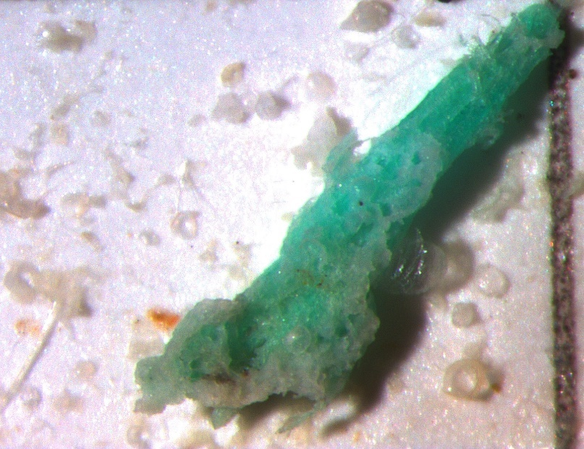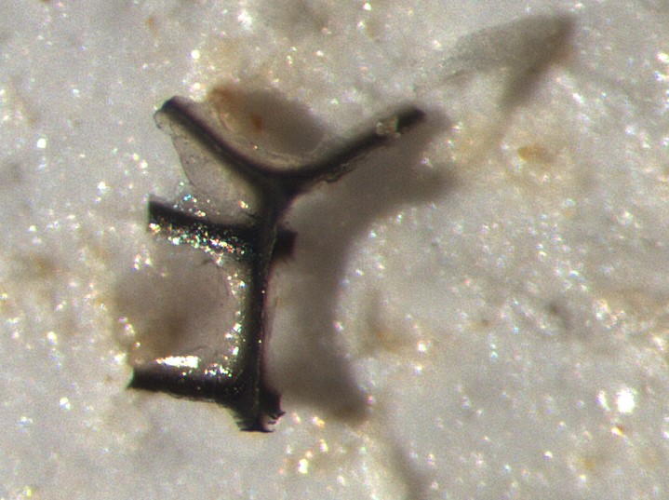

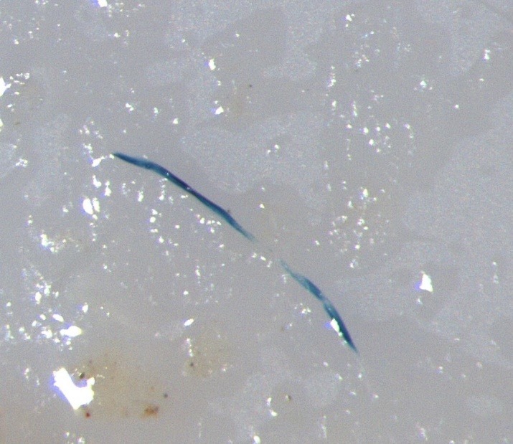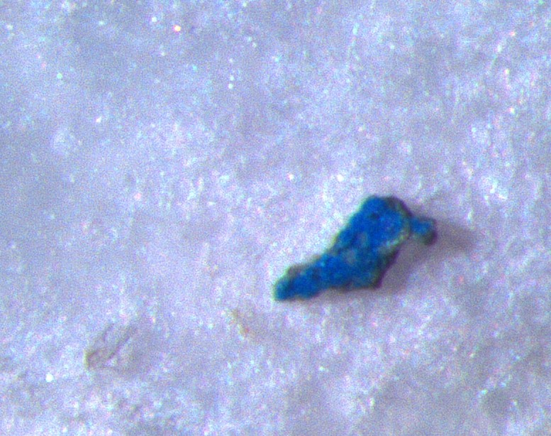

## Processing of samples 901-906

**Samples St901-906**

First time sampling: 5th of April 2019

All the samples were put into the fridge until further processing on the 20th of June 2019

**20.06.2019**

Process samples St901, St902, St903

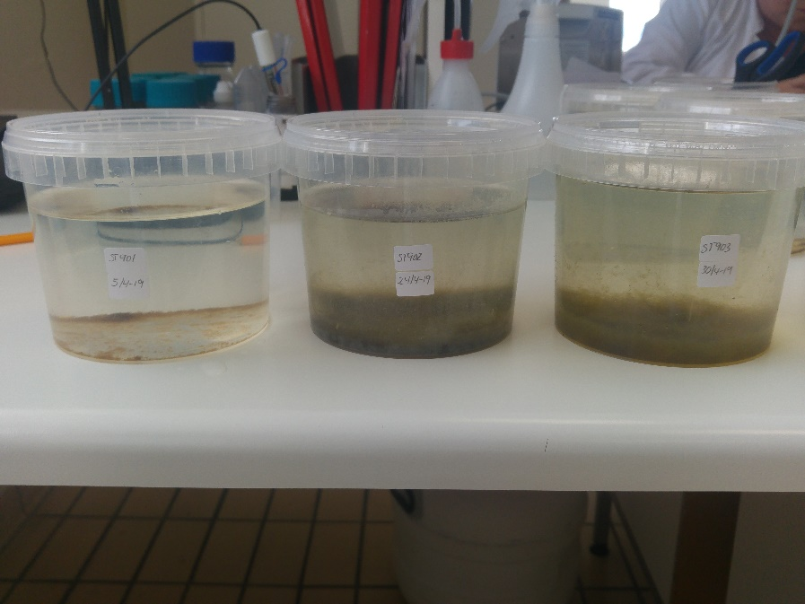

Figure St901, St902 and St903 in sampling containers

**21.06.2019**

Process samples St904, St905, St906

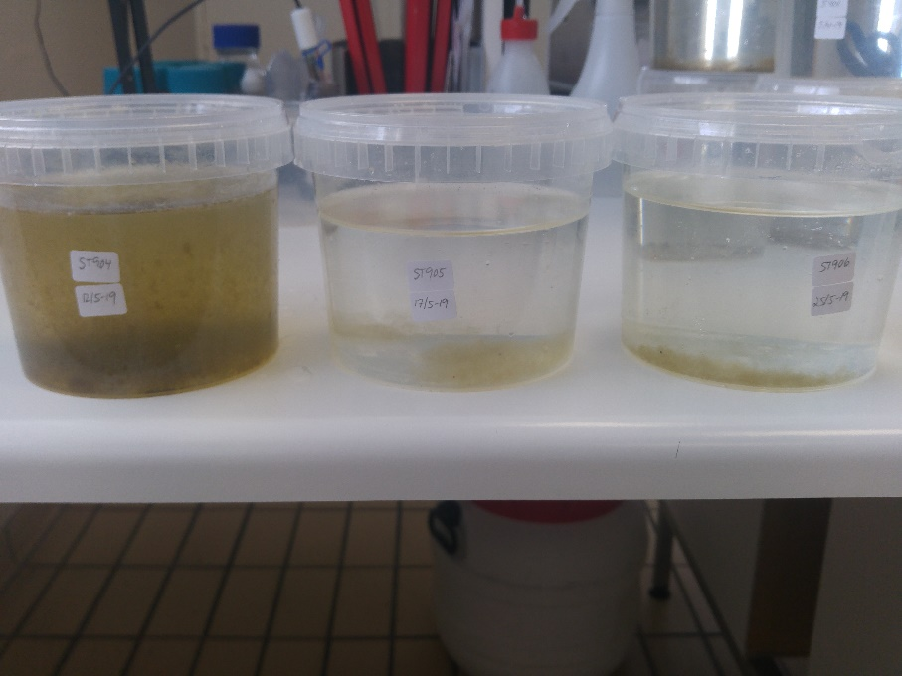

Figure St904, St905 and St906 in sampling containers

Bacteria growth appeared to have happened in the fridge as no preservative had been added nor were the samples frozen between sampling time and processing time!

Therefore the next step was carried out under the fume hood instead of the clean bench.

The samples were filtered and rinsed with fresh milliQ water through a 125 um steal mesh.

The solids were transferred into a 100 ml buffer flask. The buffer flaskes had been rinsed 3 times with hot water and 3 times with MilliQ water under the fume hood prior to the transference of the samples.

Frozen at -70 °C and freeze dried from the 21.06.2019 until the 25.06.2019 (picture 3).

Samples ST 902. 903, 904 were very dense and difficult to filter! -> check under the stereo microscope what is the dominant solid substance?

After freeze drying the samples were weighed (table 1).

|  |  |  |  |  |
| --- | --- | --- | --- | --- |
| **Sample** | **Weight**  **(tare+dry sample)**  **[g]** | **Weight**  **(tare)**  **[g]** | **Weight dry sample**  **[g]** | **Average**  **[g]** |
| **St 901 A** | 155,6245 | 155,5985 | 0,0260 | 0,0565 |
| **St 901 B** | 145,7002 | 145,6473 | 0,0529 |
| **St 901 C** | 143,6261 | 143,5355 | 0,0906 |
|  |  |  |  |  |
| **St 902 A** | 145,8300 | 145,3539 | 0,4761 | 0,2974 |
| **St 902 B** | 146,0412 | 145,7334 | 0,3078 |
| **St 902 C** | 156,1676 | 156,0593 | 0,1083 |
|  |  |  |  |  |
| **St 903 A** | 144,9754 | 144,5686 | 0,4068 | 0,3468 |
| **St 903 B** | 146,1568 | 145,8601 | 0,2967 |
| **St 903 C** | 156,3493 | 156,0125 | 0,3368 |
|  |  |  |  |  |
| **St 904 A** | 143,5636 | 143,4442 | 0,1194 | 0,2270 |
| **St 904 B** | 144,6937 | 144,628 | 0,0657 |
| **St 904 C** | 155,5353 | 155,4934 | 0,0419 |
|  |  |  |  |  |
| **St 905 A** | 142,728 | 142,6957 | 0,0323 | 0,0292 |
| **St 905 B** | 145,4447 | 145,4211 | 0,0236 |
| **St 905 C** | 145,2032 | 145,1661 | 0,0317 |
|  |  |  |  |  |
| **St 906 A** | 145,1154 | 145,082 | 0,0334 | 0,0328 |
| **St 906 B** | 157,1928 | 157,1668 | 0,0260 |
| **St 906 C** | 147,4242 | 147,3851 | 0,0391 |

Table 3 Weight of samples after freeze drying

Notes:

Use big enough flasks – I found 250 ml flasks ideal for this kind of protocol.

Don’t use any glass fibre filters – they shed fibers and it is even harder to see transparent plastic fibres.

Freeze dry the samples instead of oven dry – this makes it easier to desolve the organic mater with chemicals.

**25.06.2019**

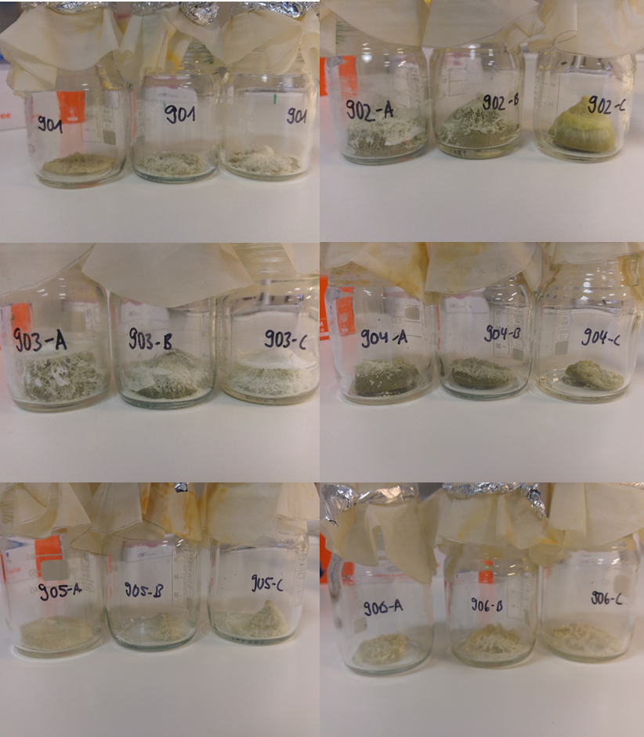

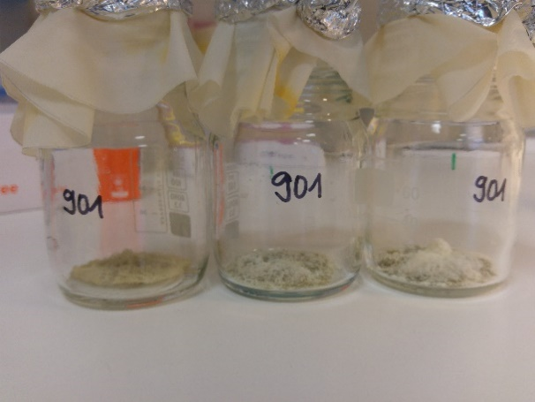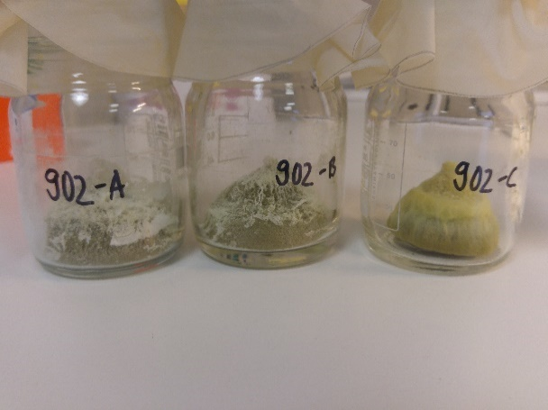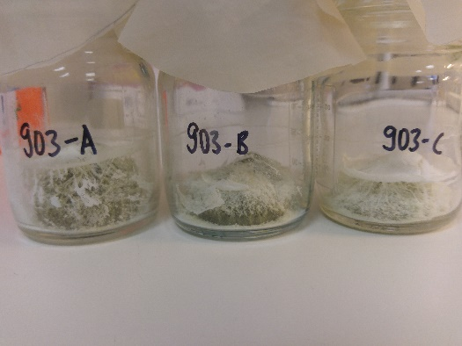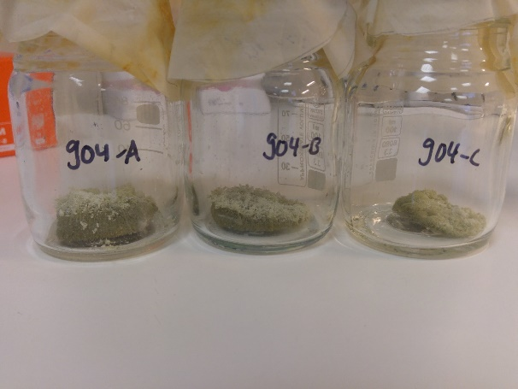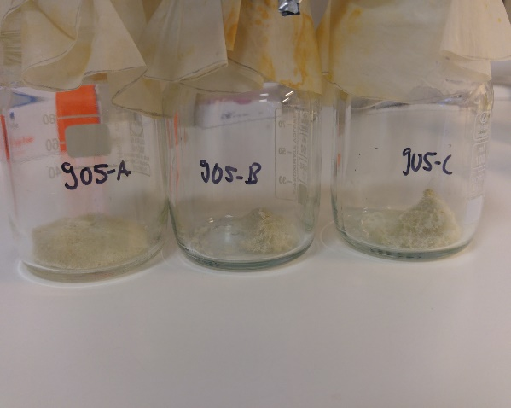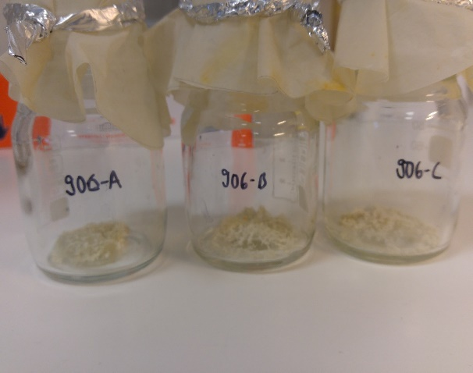

Figure St 901-906 freeze dried samples

**25.06.2019**

10 % KOH was added to the samples. Different amount of KOH was added according to the amount of solids left in the buffer flaskes after freeze drying (see table 2).

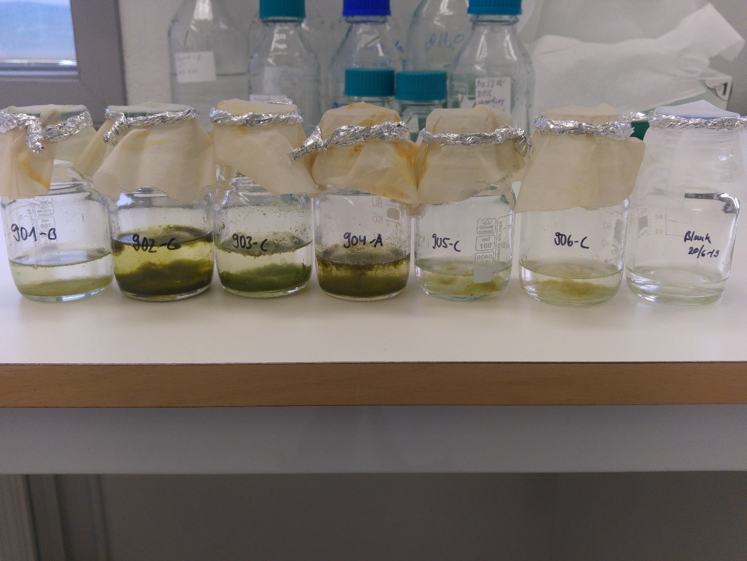

Figure St 901-906 after KOH addition

The samples were incubated at 40 °C at 150 rmp for 53 hours.

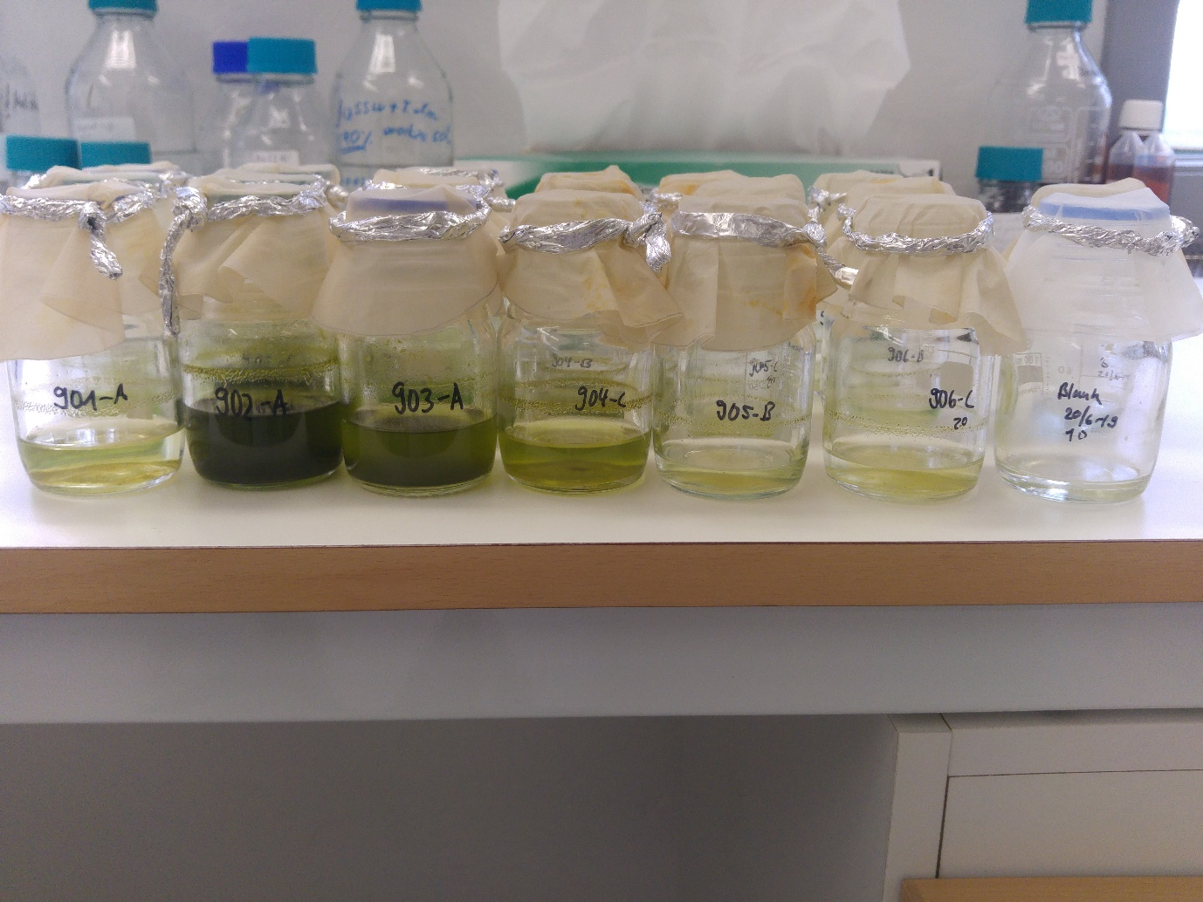

Figure St 901-906 after KOH incubation

**27.06.2019**

H2O2 was added according to the amount of solids left in the bottles and according the the amount of 10 % KOH which had been added previously.

NB: When adding H2O2 the solution gets hot and needs to be cooled under cold water to not exceed the temperature of 40 °C!

NB: Use bigger bottles – like 250 ml erlenmayer flasks instead of 100 ml buffer flasks. As foaming can occur during the addtion of H2O2!

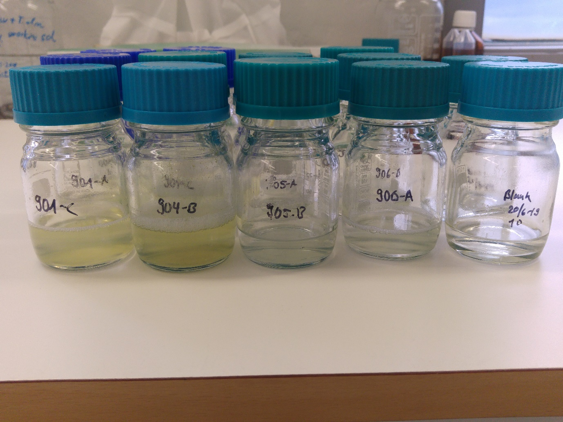

Figure After H2O2 incubation

|  |  |  |  |  |  |  |
| --- | --- | --- | --- | --- | --- | --- |
| Sample | 10 % KOH added | KOH incubation time | 35 % H2O2 added | Final conc.  of H2O2  [%] | H2O2  incubation | Samples filtered |
| St 901 A | 30 ml | Start 25/6/19  15:00  End: 27/6/19  10:00  53 hours  40 °C | 10 | 8,75 | 40 °C 20 h | 28/6/19 |
| St 901 B | 10 | 8,75 |
| St 901 C | 10 | 8,75 |
|  |  |  |  |  |  |
| St 902 A | 50 ml | 25 | 12 | RT 20 h,  72 h at  40 °C | 1/7/19 |
| St 902 B | 25 | 12 |
| St 902 C | 15* | 8,1 |
|  |  |  |  |  |  |
| St 903 A | 40 ml | 20 | 12 | RT 20 h, 72 h at  40 °C | 1/7/19 |
| St 903 B | 20 | 12 | RT 20 h, 72 h at  40 °C; ** |
| St 903 C | 20 | 12 | RT 20 h, 72 h at  40 °C ** |
|  |  |  |  |  |  |
| St 904 A | 30 ml | 15 | 12 | 40 °C 20 hours *** | 28/6/19 |
| St 904 B | 15 | 12 |
| St 904 C | 15 | 12 |
|  |  |  |  |  |  |
| St 905 A | 20 ml | 10 | 12 | 40 °C 20 hours | 28/6/19 |
| St 905 B | 10 | 12 |
| St 905 C | 10 | 12 |
|  |  |  |  |  |  |
| St 906 A | 20 ml | 10 | 12 | 40 °C 20 hours | 28/6/19 |
| St 906 B | 10 | 12 |
| St 906 C | 10 | 12 |
| *Only 15 ml H2O2 could be added because of too much foaming | | | | | |  |
| ** Lost some material because of lots of foaming | | | | | |  |
| *** Some material was stuck on the lid but foam did not come out of the bottle like in St 902 and 903 | | | | | |  |

Table St 901-906 Amount of KOH and H2O2 added

**28.06.2019 and 1.07.2019**

After H2O2 incubation the solution was filtered through the 125 µm steal mesh. The bottles were rinsed well with MilliQ water. The solids were transferred onto a GF/C filter. The filter was transferred into a sterile petri dish and frozen at -20 °C.

## Processing of samples 907-909

**St 907-909**

**26.6.2019**

Processing of samples St907-909. Filter the samples through a 125 µm mesh and collect the solids in a 250 ml Erlenmeyer flask. Freeze at -70 °C and freeze dry for 48 hours.

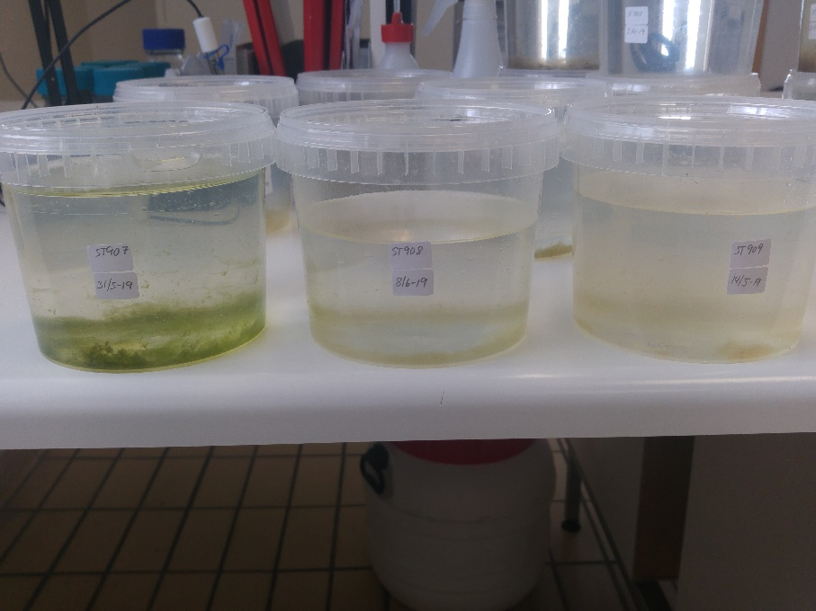

Figure St 907-909 samples in sampling containers

|  |  |  |  |  |
| --- | --- | --- | --- | --- |
| Sample | Weight (tare+dry sample) [g] | Weight (tare) [g] | Weight dry sample  [g] | Average  dry weight  [g] |
| St 907 A | 123,0955 | 123,0481 | 0,0474 | 0,0420 |
| St 907 B | 128,1209 | 128,0802 | 0,0407 |
| St 907 C | 128,5356 | 128,4976 | 0,0380 |
|  |  |  |  |  |
| St 908 A | 124,9153 | 124,8725 | 0,0428 | 0,0440 |
| St 908 B | 127,9799 | 127,9520 | 0,0279 |
| St 908 C | 128,0869 | 128,0257 | 0,0612 |
|  |  |  |  |  |
| St 909 A | 123,7704 | 123,6749 | 0,0955 | 0,0972 |
| St 909 B | 124,2833 | 124,2210 | 0,0623 |
| St 909 C | 125,3693 | 125,3308 | 0,0385 |

Table St 907-909 Weight of after freeze drying

**28.06.2019**

20 ml of 10 % KOH was added into each of the bottles and incubated at 40 °C (without shaking) for 96 hours.

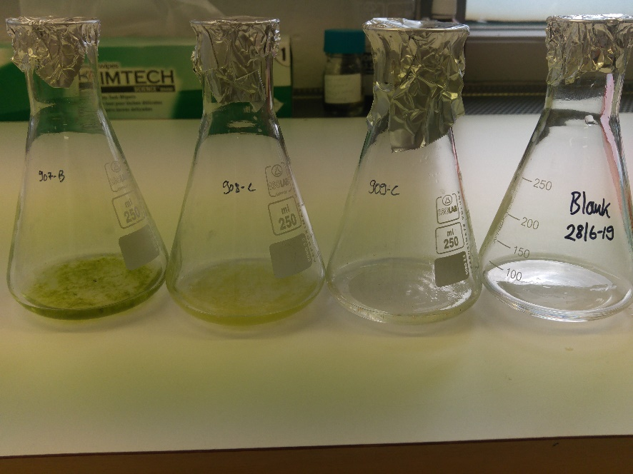

Figure St 907-909 Samples after KOH was added

**02.07.2019**

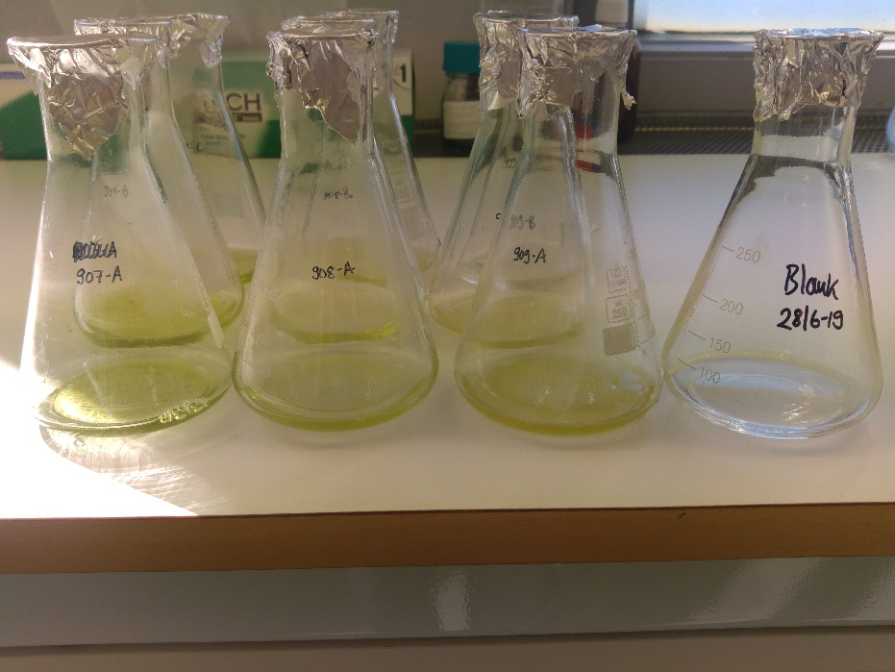

Figure St 907-909 Samples after KOH digestion

**02.07.2019**

20 ml of 30 % H2O2 was added at put at 40 °C (without shaking) for 24 hours.

**03.07.2019**

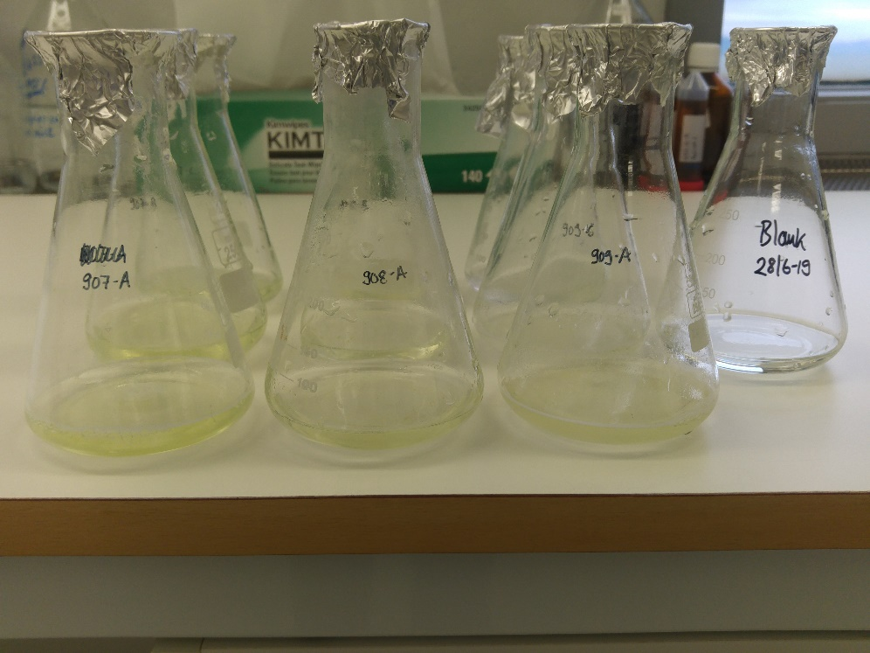

Figure St 907-909 Samples after H2O2 digestion

The samples were filtered through 125 µm mesh and transferred onto a Durapore membrane filter (0,22 µm).

Filters were transferred into a sterile petri dish and sealed with parafilm and frozen at -20°C.

|  |  |  |  |
| --- | --- | --- | --- |
| Sample | 10 % KOH | 30 % H2O2 | Final concentration of H202 |
| St 907 A | 20 ml  40 °C (without shaking) for 96 hours | 20 ml  40 °C (without shaking) for 24 hours | 15 % |
| St 907 B |
| St 907 C |
|  |
| St 908 A |
| St 908 B |
| St 908 C |
|  |
| St 909 A |
| St 909 B |
| St 909 C |

Table 3 St 907-909 Amount of KOH and H2O2 added

## Processing of samples 910-911

**St 910 and St 911**

2.07.2019

Transfere the solids under the clean bench into 250 ml erlenmeyer flasks. Freeze dry for 2 days.

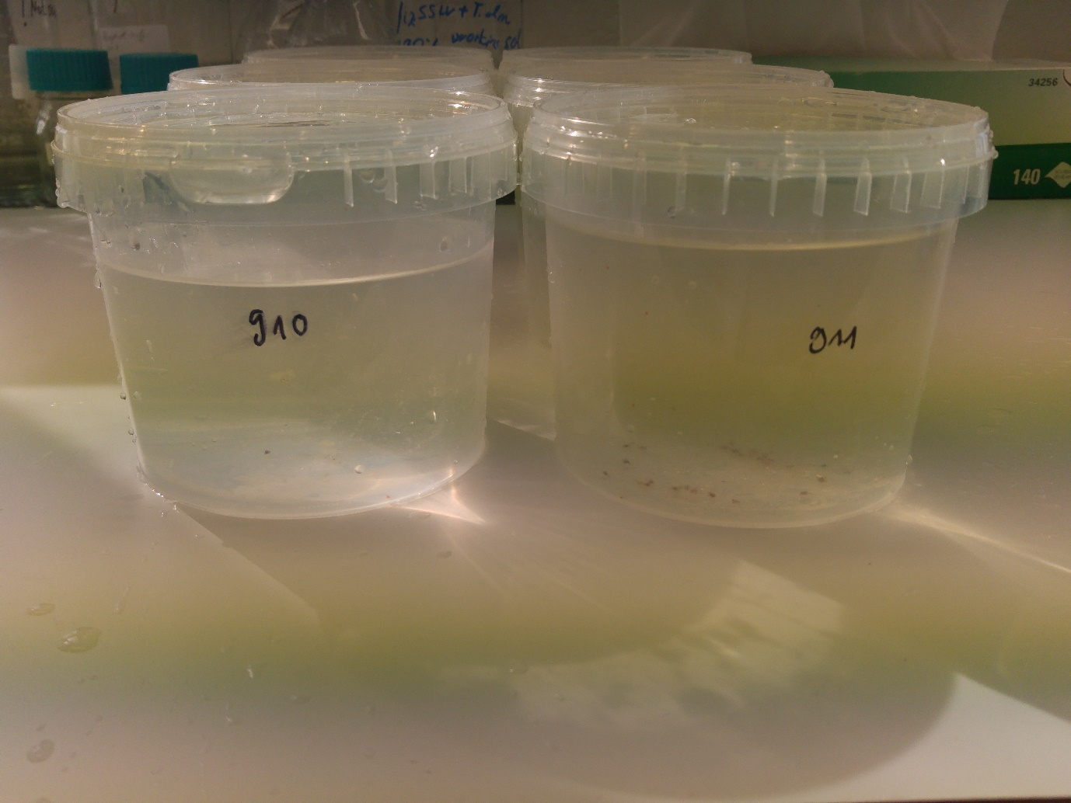

Figure St910 and 911 in sample containers

4.07.2019

After freeze drying take the weight of the tare+dry weight and put the samples in the fridge to await further processing.

|  |  |  |  |  |
| --- | --- | --- | --- | --- |
| Sample | Weight (tare+dry sample) [g] | Weight (tare) [g] | Weight dry sample  [g] | Average  dry weight  [g] |
| St 910 A | 114,2452 | 114,2260 | 0.0192 | 0.02 |
| St 910 B | 136,3754 | 136,3544 | 0.021 |
| St 910 C | 113,1500 | 113,1220 | 0.028 |
|  |  |  |  |  |
| St 911 A | 126,4195 | 126,3825 | 0.0370 | 0.06 |
| St 911 B | 114,7325 | 114,6764 | 0.0561 |
| St 911 C | 133,7741 | 133,6990 | 0.0751 |
|  |  |  |  |  |
| Blank | 121,3685 | 121,3602 | 0.0083 |  |

22/7/19

20 ml of 10 % KOH was added into each of the bottles and incubated at 40 °C (without shaking) for 48 hours.

24/7/19

Into St 910 and into the blank 10 ml of H2O2 (30 %) was added and into St 911 20 ml of H2O2 (30 %) was added. Incubate the samples for 24 hours at RT and 24 hours at 40 °C.

26/7/19

Filter the samples St910 and the blank directly on nitrocellulose membrane filters. Prefilter samples St911 though a 125 um metal mesh first before transferring the remaining solids onto nitrocellulose membrane filters.

## Processing of samples 912-914

**St 912 - 914**

22/7/19

Process 912-914. A blank was taken onboard while taking the samples; 1000 ml plastic containers (same as for samples) were filled half way with milliQ water prior to sampling. During sampling the container was opened and kept open during the entire sampling process. The blank water samples were treated the same way as the samples.

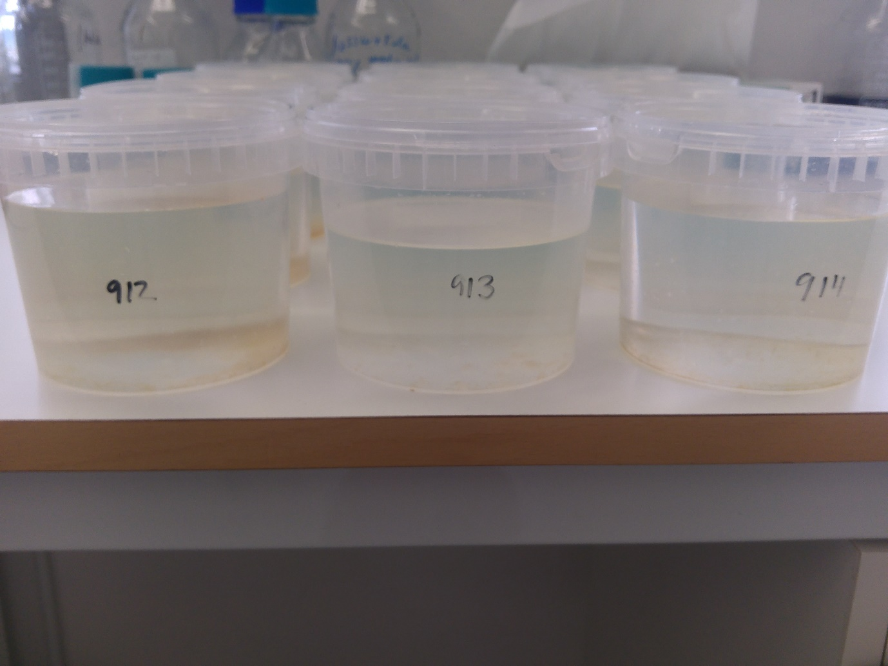

Figure St 912, St 913 and 914 in sample containers

Filter samples and blanks through 125 um steel mesh into a 250 ml Erlenmeyer flask. Samples were dried in the freeze dryer for 48 hours.

|  |  |  |  |  |
| --- | --- | --- | --- | --- |
| Sample | Weight (tare) [g] | Weight (tare+dry sample) [g] | Weight dry sample  [g] | Average  dry weight  [g] |
| St 912 A | 124,7782 | 124,8279 | 0.0497 | 0.07 |
| St 912 B | 112,9360 | 113,0149 | 0.0789 |
| St 912 C | 145,3403 | 145,4276 | 0.0873 |
| Blank | 118,7060 | 118,7104 | 0.0044 |  |
|  |  |  |  |  |
| St 913 A | 111,8754 | 111,8960 | 0.0206 | 0.03 |
| St 913 B | 113,8827 | 113,9190 | 0.0363 |
| St 913 C | 124,9220 | 124,9595 | 0.0375 |
| Blank | 113,1773 | 113,1827 | 0.0054 |  |
|  |  |  |  |  |
| St 914 A | 127,4432 | 127,4939 | 0.0507 | 0.05 |
| St 914 B | 124,5401 | 124,5783 | 0.0382 |  |
| St 914 C | 125,5011 | 125,5518 | 0.0507 |  |
| Blank | 112,6502 | 112,6512 | 0.001 |  |

26/7/19

Add 20 ml of 10 % KOH into the samples and 10 ml of 10 % KOH into the blank samples. Let it incubate for 48 hours at 40 °C (without shaking).

29/7/19

Add 20 ml of 30 % H2O2 into St 912 and 10 ml of 30 % H2O2 into the remaining samples/blanks. Incubate at RT for 24 hours and at 40 °C for another 24 hours.

31/ 7/19

Filter the samples on

|  |  |  |  |
| --- | --- | --- | --- |
| 910-C | Lots of paint and rusty bits from the boat |  |  |
| 911-A | Rust and paint from boat |  |  |
| Blank 910 and 911 | One blue/black fibre |  |  |

NB

Use gridded filterpaper which makes it easier to keep track while identifying microplastics under the microscope

Almost impossible to identify transparent microplastics with microscope identification

## Processing of samples 915-917

27/8/19

Filter samples and blanks through 125 um steel mesh into a 250 ml Erlenmeyer flask. Samples were dried in the freeze dryer for 120 hours (until the 1/9/19).

|  |  |  |  |  |
| --- | --- | --- | --- | --- |
| Sample | Weight (tare) [g] | Weight (tare+dry sample) [g] | Weight dry sample  [g] | Average  dry weight  [g] |
| St 915 A | 112,6802 | 112,6910 | 0,0108 | |  | | --- | | 0.0277 | |  | |  | |
| St 915 B | 120,1569 | 120,1825 | 0,0256 |
| St 915 C | 111,8573 | 111,9040 | 0,0467 |
| Blank | 127,4348 | 127,4251 | -0,0097 | - |
|  |  |  |  |  |
| St 916 A | 133,2689 | 133,3454 | 0,0765 | |  | | --- | | 0.0435 | |  | |
| St 916 B | 123,2128 | 123,2442 | 0,0314 |
| St 916 C | 111,8370 | 111,8595 | 0,0225 |
| Blank | 124,9051 | 124,9016 | -0,0035 | - |
|  |  |  |  |  |
| St 917 A | 127,4150 | 127,8851 | 0,4701 | |  | | --- | | 0.3144 | |
| St 917 B | 113,5050 | 113,7399 | 0,2349 |
| St 917 C | 112,6555 | 112,8937 | 0,2382 |
| Blank | 128,4264 | 128,4180 | -0,0084 | - |

**NB: Blanks are just filtered water and not the blanks from sampling at sea. The blanks from sampling at sea were filtered directly on a filter paper without processing it any further.**

20/9/19

Add 10 ml of 10 % KOH into all blanks and into St 915 and St 916. Add 20 ml of 10 % KOH into St 917.

Incubate at 40 degrees for 3 days

23/9/19

Add 10 ml of 30 % H2O2 into all blanks and into St915 and St916. Add 20 ml into St 917.

NB: Samples from 917 could almost not be determined because of a high content of organic matter which seems to be leftovers from dinoflagellates.

30/9/19

Filter the samples through a steal mesh and put on a filter paper.

## Processing of samples 918-920

1/10/19

Wash Erlenmeyer flasks, dry them and take tare. Filter samples 918-920 through 125 um mesh and transfer into the flasks. Freeze dry and weigh the dried samples afterwards.

|  |  |  |  |  |
| --- | --- | --- | --- | --- |
| Sample | Weight (tare) [g] | Weight (tare+dry sample) [g] | Weight dry sample  [g] | Average  dry weight  [g] |
| St 918 A | 125,0568 | 125,0805 | 0.0237 | 0.021467 |
| St 918 B | 131,6374 | 131,6646 | 0.0272 |
| St 918 C | 114,7087 | 114,7222 | 0.0135 |
|  |  |  | 0 |  |
| St 919 A | 114,3735 | 114,4787 | 0.1052 | 0.070567 |
| St 919 B | 121,0868 | 121,1390 | 0.0522 |
| St 919 C | 157,9639 | 158,0182 | 0.0543 |
|  |  |  | 0 |  |
| St 920 A | 123,4398 | 123,4616 | 0.0218 | 0.0237 |
| St 920 B | 126,2974 | 126,3227 | 0.0253 |
| St 920 C | 113,6592 | 113,6832 | 0.024 |
| Blank | 113,6164 | 113,6165 | 0.0001 |  |

## Processing of samples 921-922

|  |  |  |  |  |
| --- | --- | --- | --- | --- |
| Sample | Weight (tare) [g] | Weight (tare+dry sample) [g] | Weight dry sample  [g] | Average  dry weight  [g] |
| St 921 A | 114.5266 | 114.592 | 0.0654 | 0.075333 |
| St 921 B | 125.1212 | 125.2114 | 0.0902 |
| St 921 C | 123.2797 | 123.3501 | 0.0704 |
|  |  |  |  |  |
| St 922 A | 113.6428 | 113.6749 | 0.0321 | 0.038267 |
| St 922 B | 114.0719 | 114.1149 | 0.043 |
| St 922 C | 131.9091 | 131.9488 | 0.0397 |
|  |  |  |  |  |
| Blank | 115.0368 | 115.039 | 0.0022 | - |

Add 10 ml 10 % KOH into each bottle, incubate for three days at 40 C. Add 6 ml of 30 % H2O2 to St921 and incubate for some days at 40 C. Process as usually.

# RAMAN

According to Maria there is still too much organic matter left on our filters. Therefore she recommended to digest the samples again and increase the digestion time.

We chose to use the filters with the highest amount of particles numbers on them to improve digestion and to analyse with the RAMAN.

It was decided to digest 8 samples again:

|  |  |  |
| --- | --- | --- |
| **Filter ID** | **Sampling ID** | **Number of particles** |
| 44 | 914-C | 16 |
| 3 | 901-C | 14 |
| 69 | 918-C | 12 |
| 42 | 914-A | 9 |
| 16 | 906-A | 8 |
| 25 | 909-A | 8 |
| 48 | 915-C | 8 |
| 70 | 919-A | 8 |

Table Additionally digested samples for RAMAN

The following samples will be taken for RAMAN analysis but will not be digested again. The content of organic matter was not as high as in the 8 samples from above.

|  |  |  |
| --- | --- | --- |
| **Filter ID** | **Sampling ID** | **Number of particles** |
| 28 | 910-A | 11 |
| 29 | 910-B | 11 |

Table Samples for RAMAN without additional digestion

Pictures of filters chosen to take for RAMAN analysis (before additional digestion)

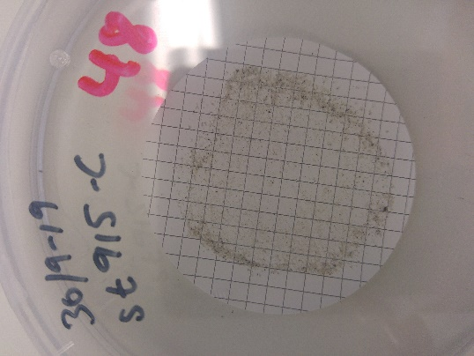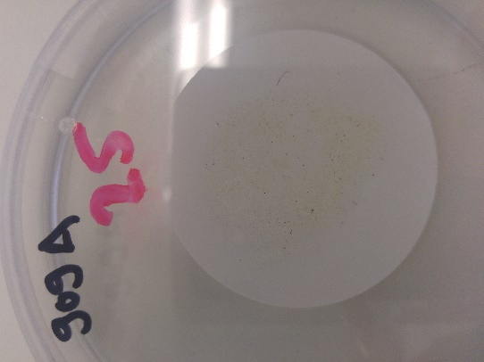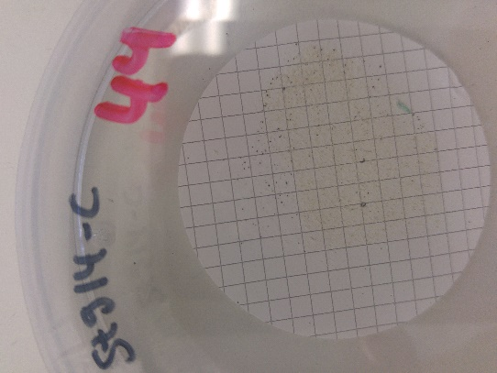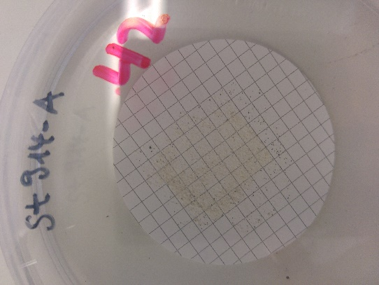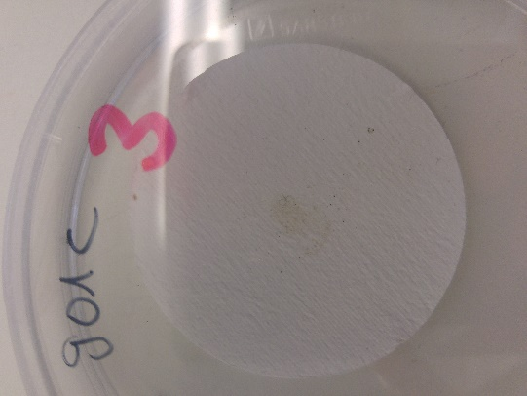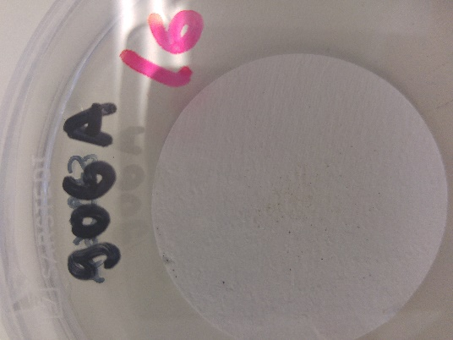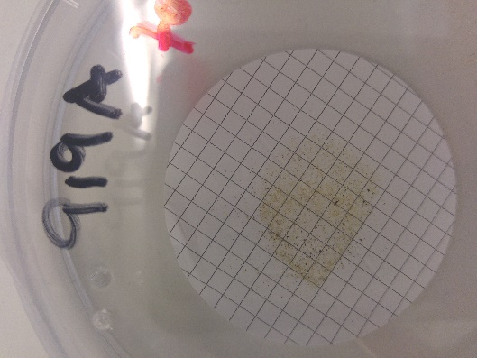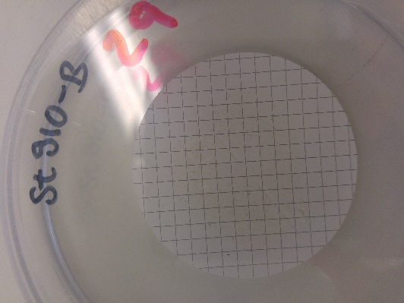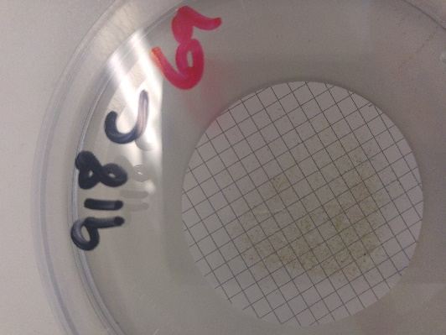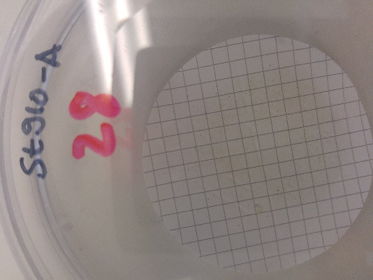

Additional digestion

1. Transfer the filters into a glass tube
2. Add 15 ml of 10 %KOH
3. Incubate at 40 C for

# Appendix

## Pictures of water samples before digestion

902: Primarily colonial marine diatom (bloom), very dense, some eggs

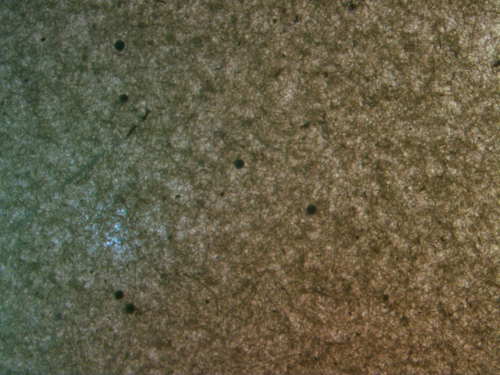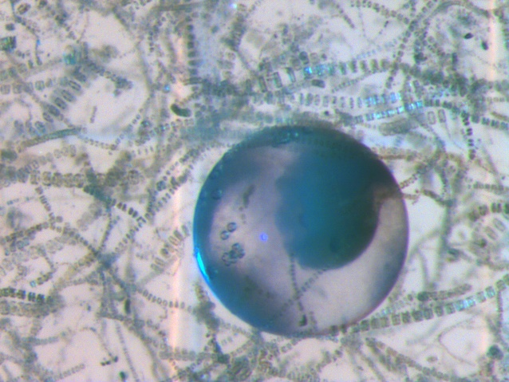

903: Primarily colonial marine diatom (bloom), very dense

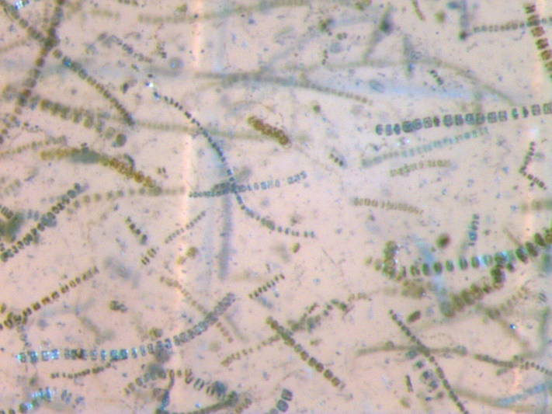

904: Primarily colonial marine diatom (bloom), very dense

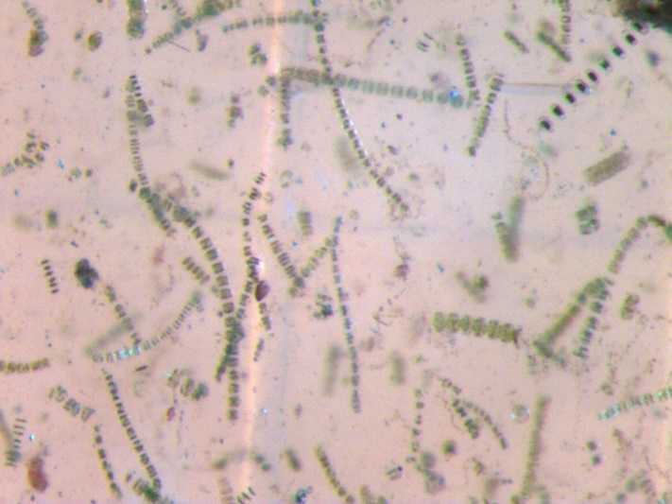

905: some colonial marine diatom, some zooplankton, some eggs

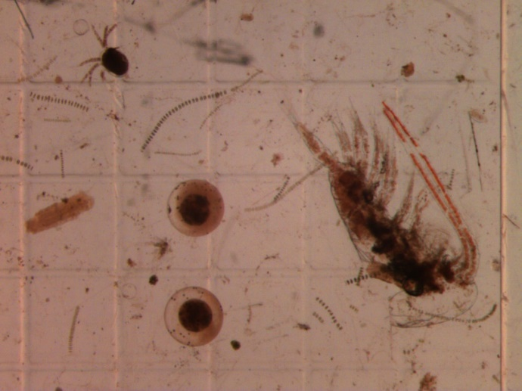

906: Only a few diatoms, eggs, zooplankton, not very dense

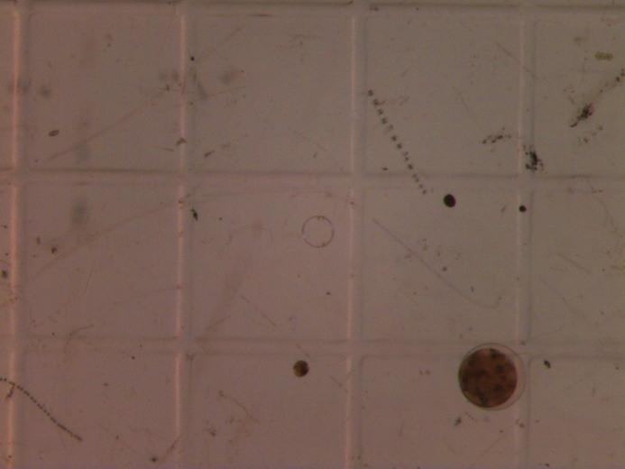

907: Only a few diatoms, eggs, zooplankton, not very dense

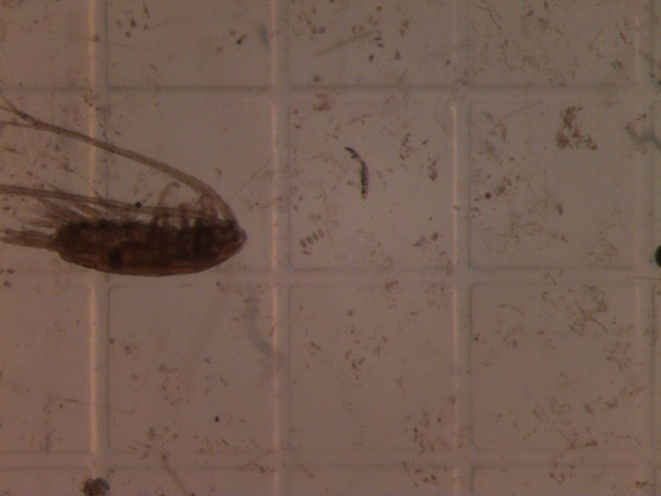

908: Denser zooplankton, denser diatom as in 907 but not as dense as 902-904

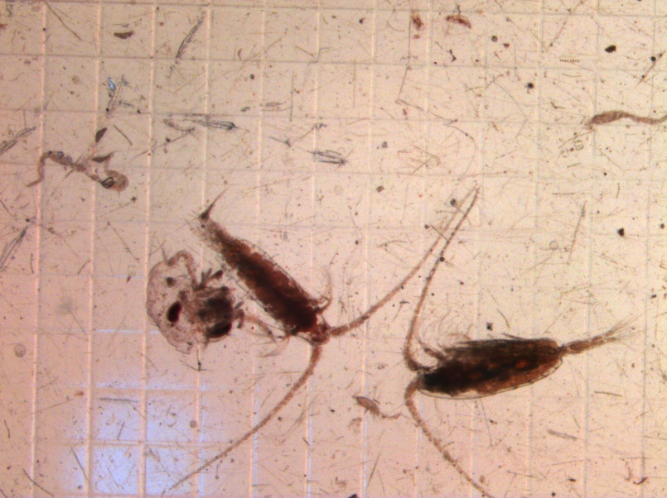

909: Lots of copepods, needle shape diatoms

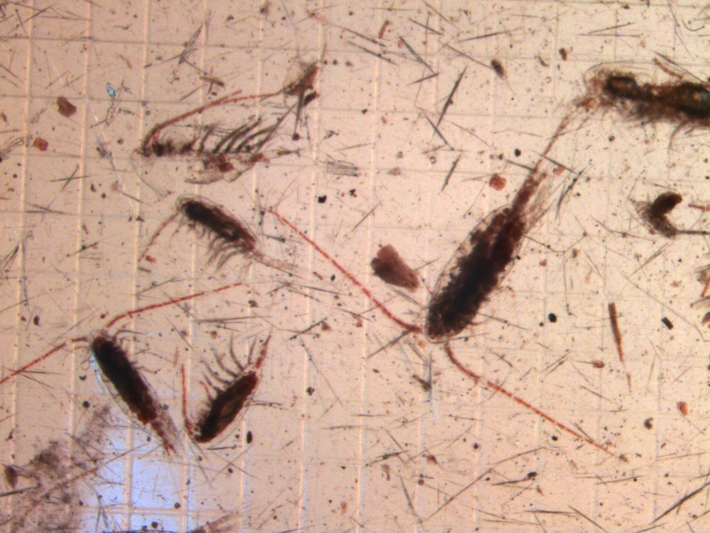

910: Lots of larvae, needle shape diatoms

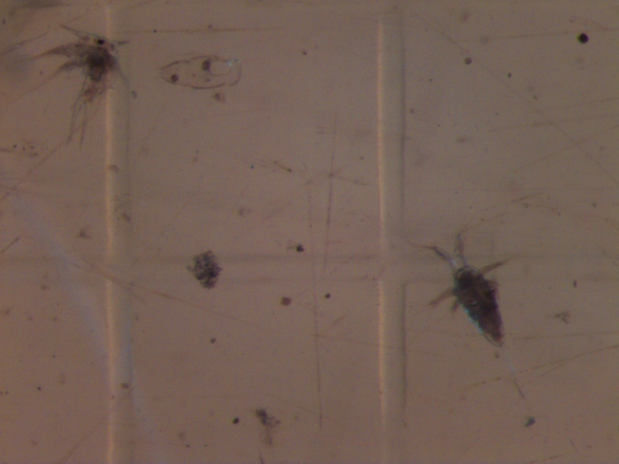

911: Diatoms, some big larvae

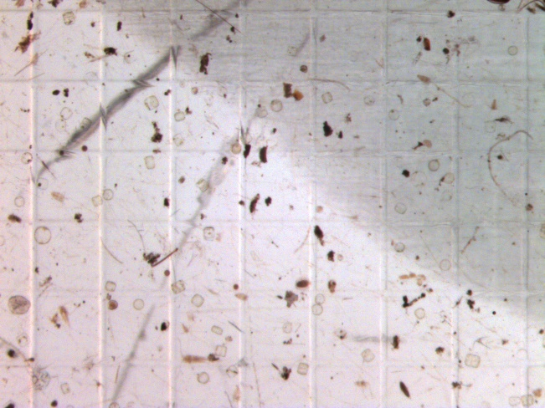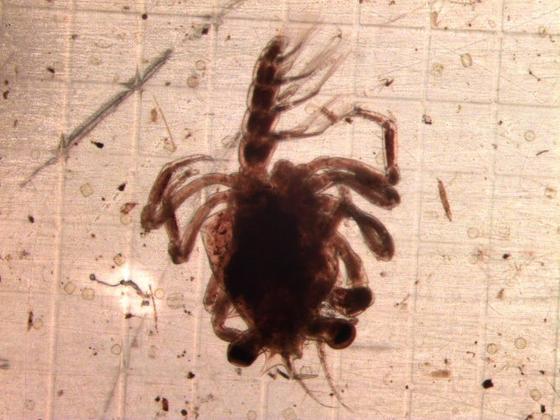

912: some diatoms, some larvae some eggs not very dense

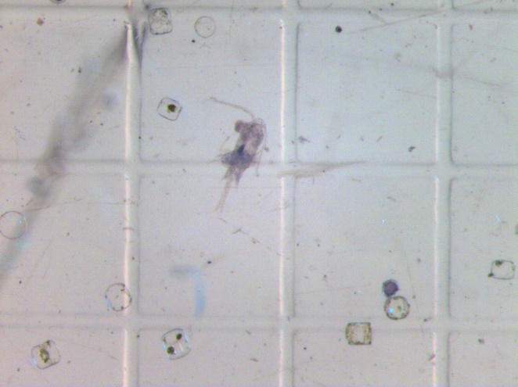

913: Some diatoms, lots of ostracods, some mussle larvae

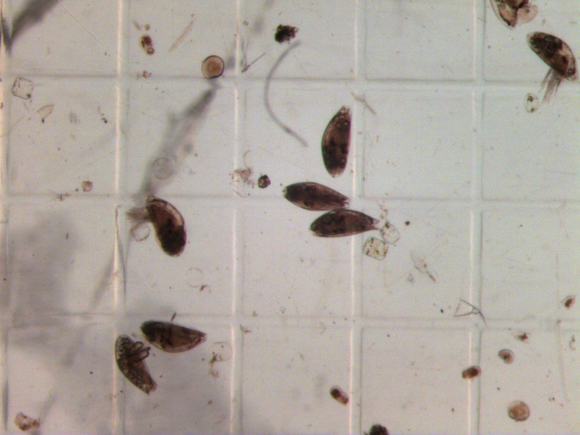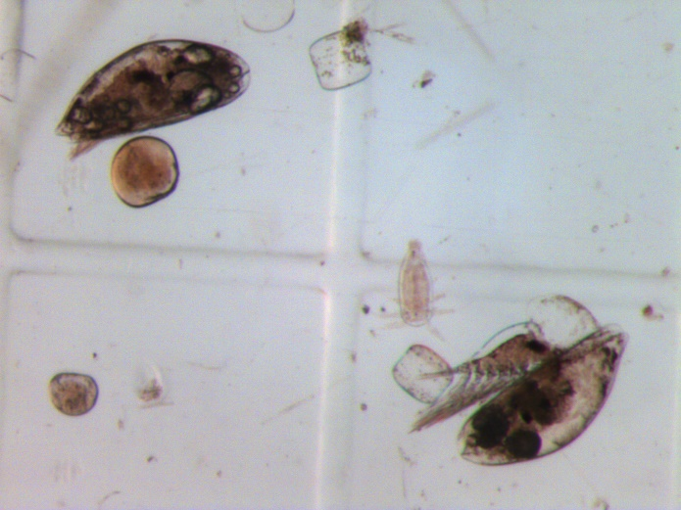

914: lots of Dinoflagelates, lots of mussle larvae and zooplankton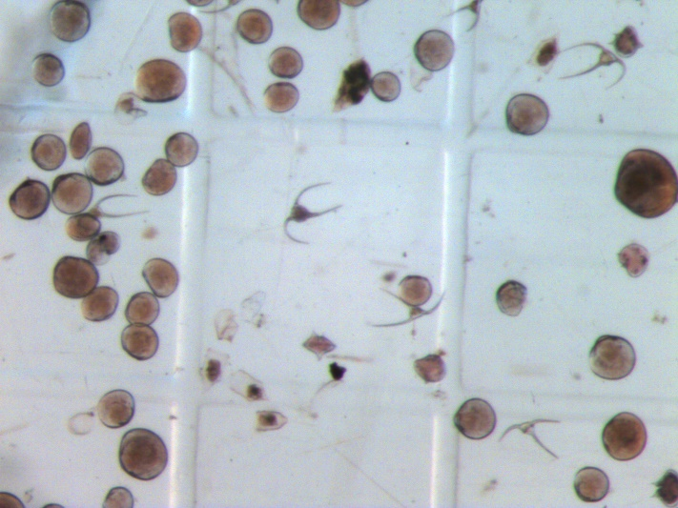

915: Some dinoflagelates, some mussle larvae, not very dense

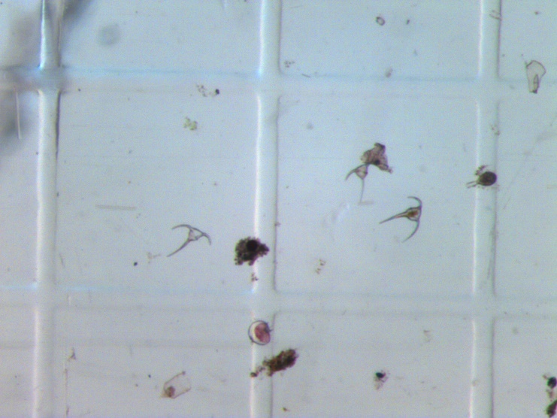

916: Lots of dinoflagelates, some larvae, some needle shape diatoms.

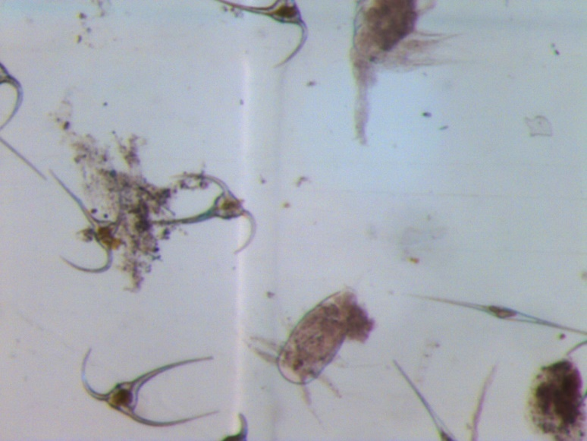

917: lot so mussel larvae, lots of dinoflagellates, and diatoms

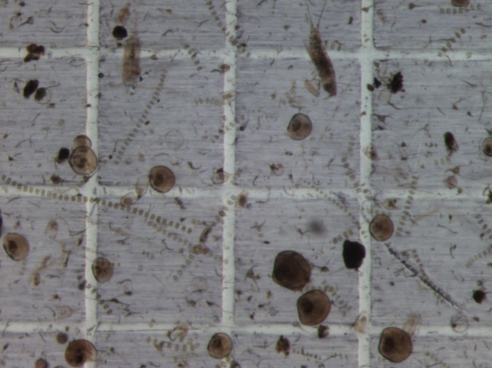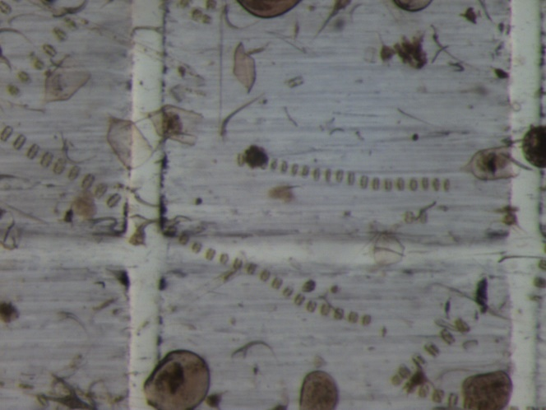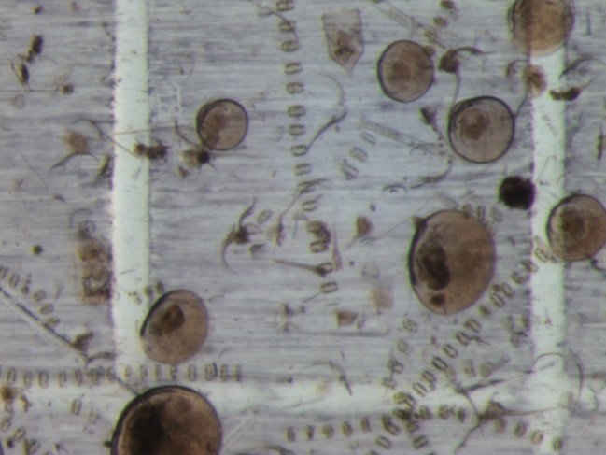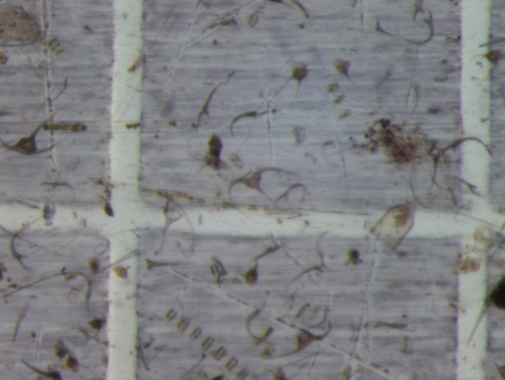

918: not a very dense sample, very few diatoms and dinoflagellates, few mussel larvae

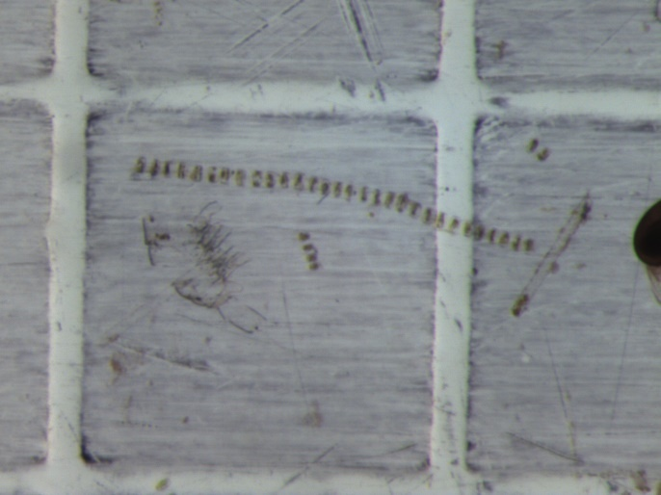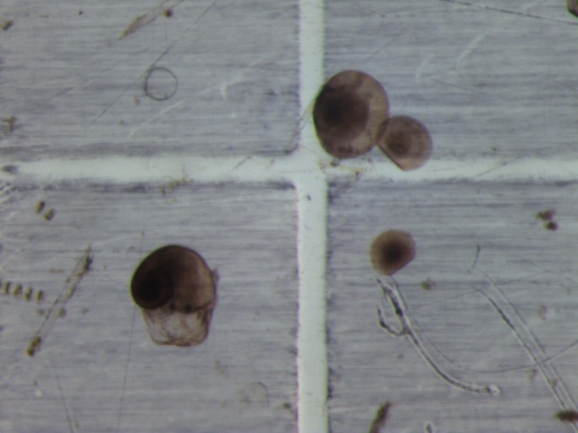

919: lots of dinoflagellates and needle shaped dinoflagellates, some diatoms, lots of mussel larvae

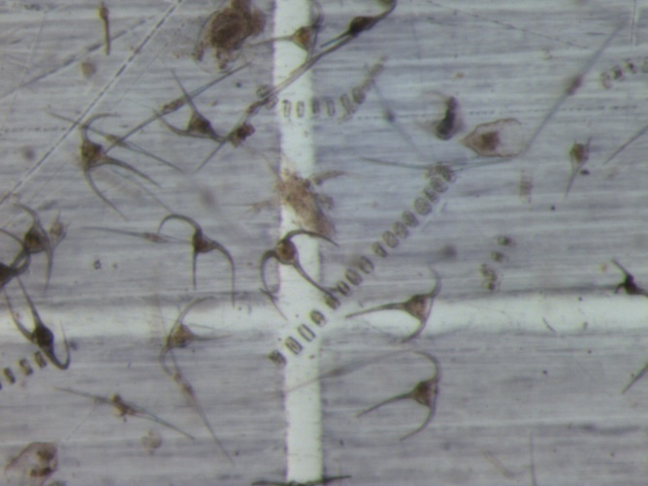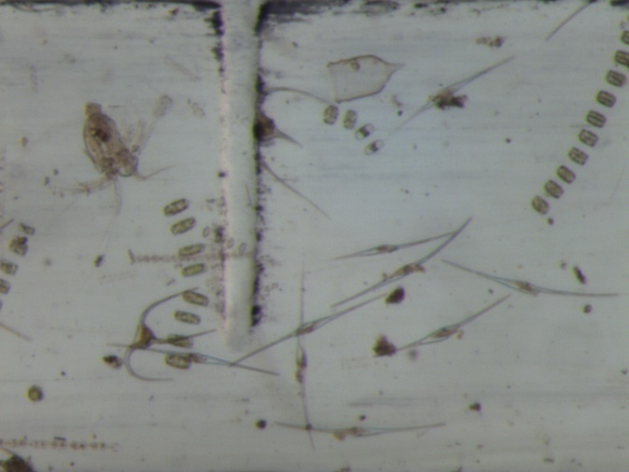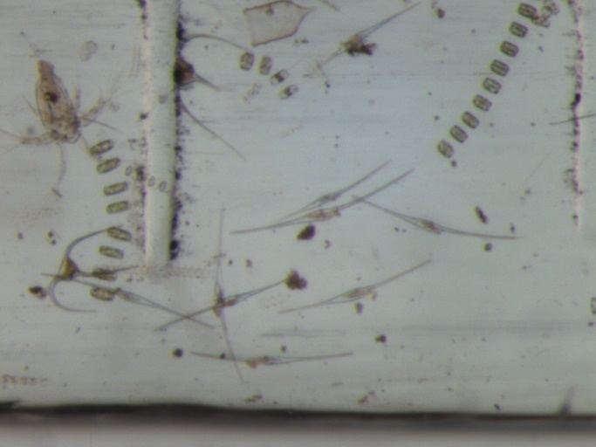

920: lots of chains of diatoms, some copepods, some dinoflagellates

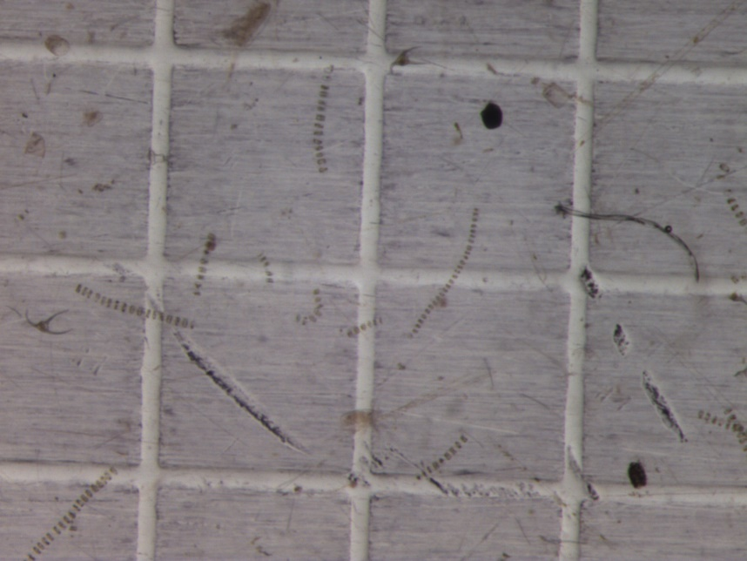

921: small snails, some copepods, dinoflagellates and some needle shaped dinoflagellates

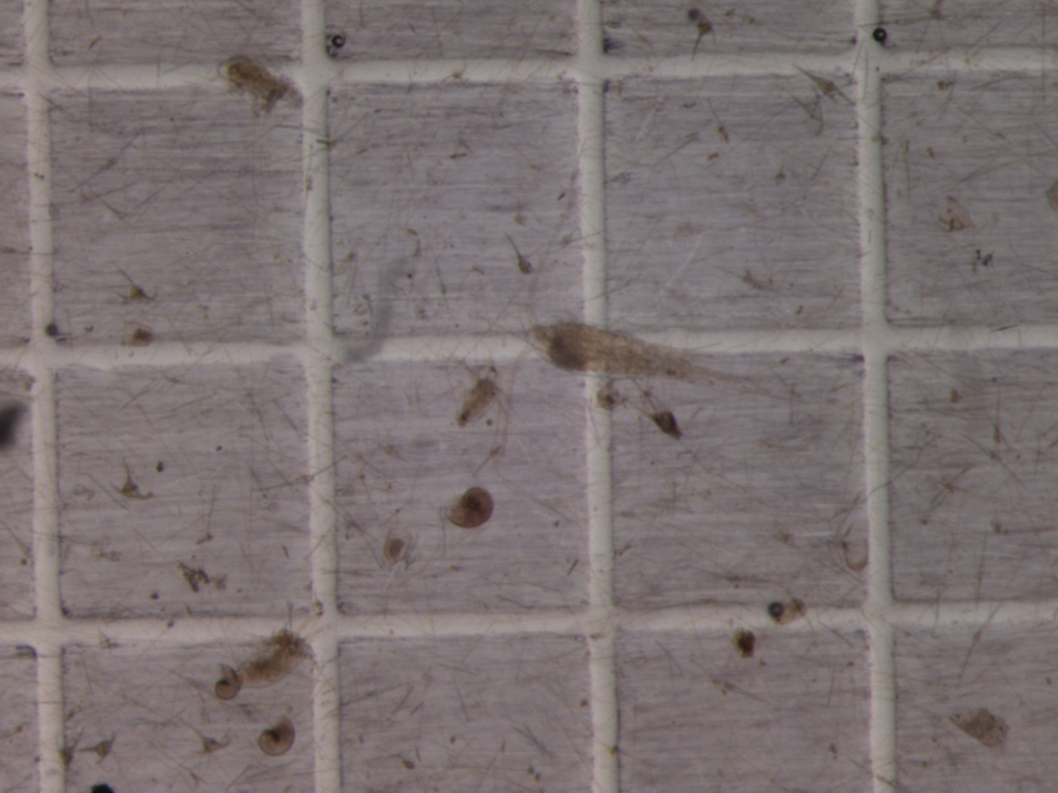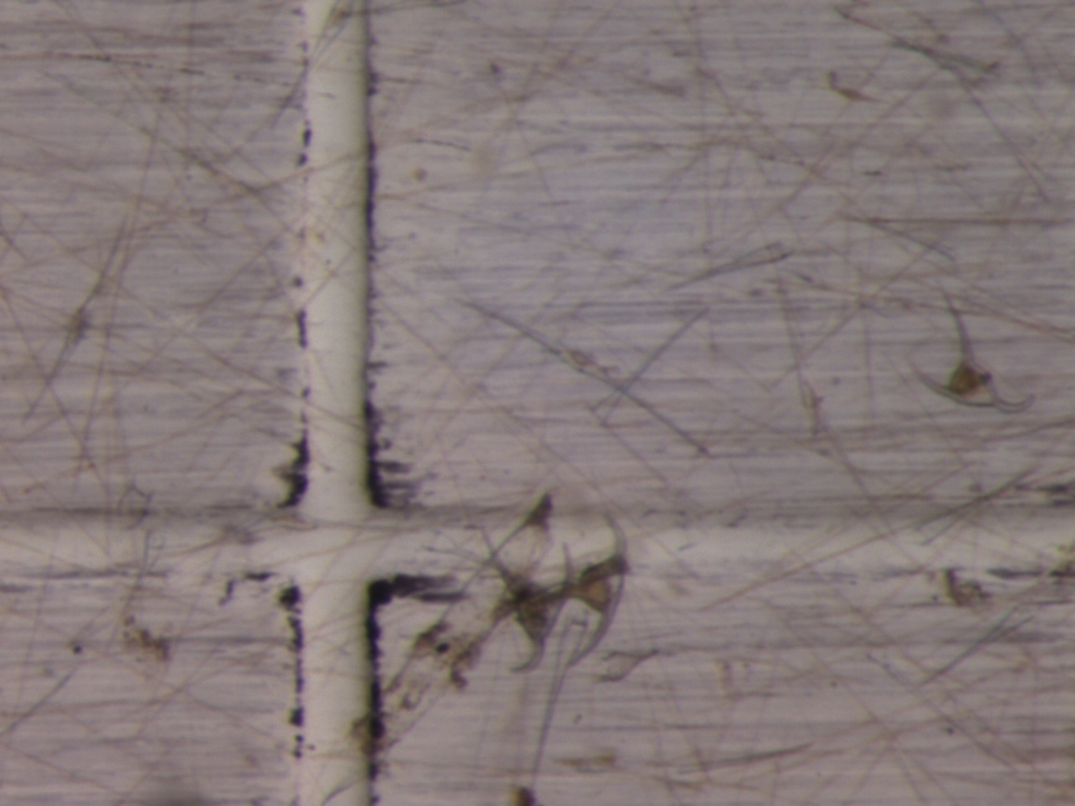

922: small snails, some copepods, dinoflagellates (less than in 921), some needle shaped dinoflagellates

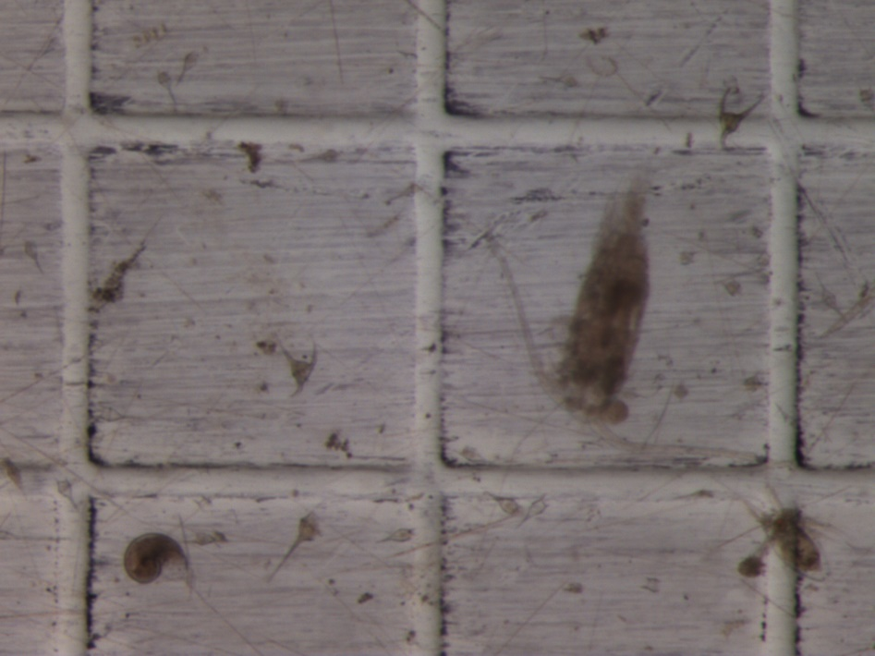

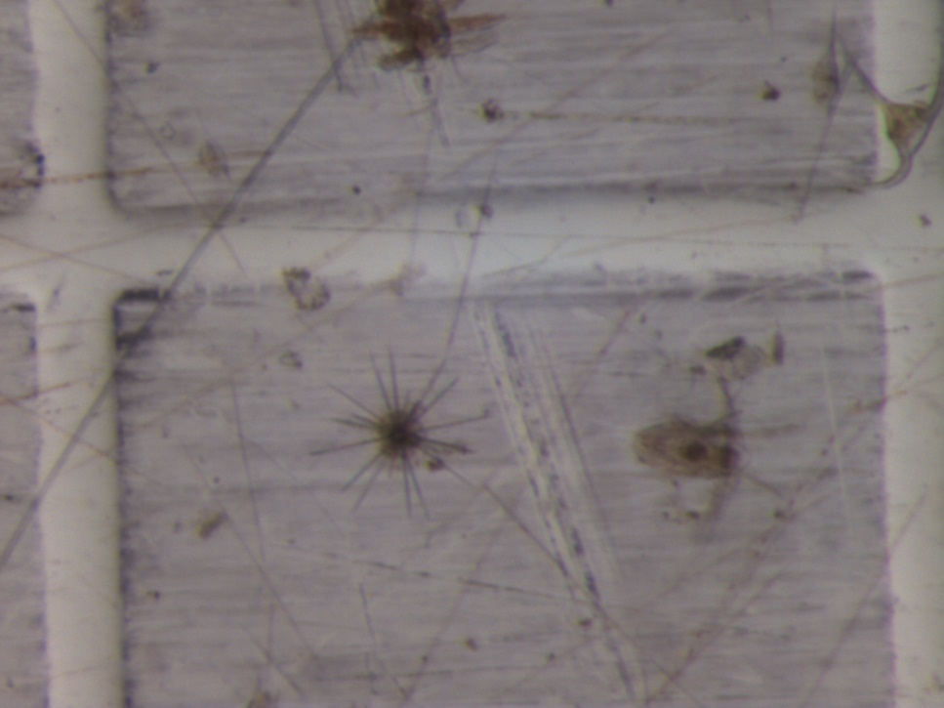

## Pictures of filters in petri dishes after digestion

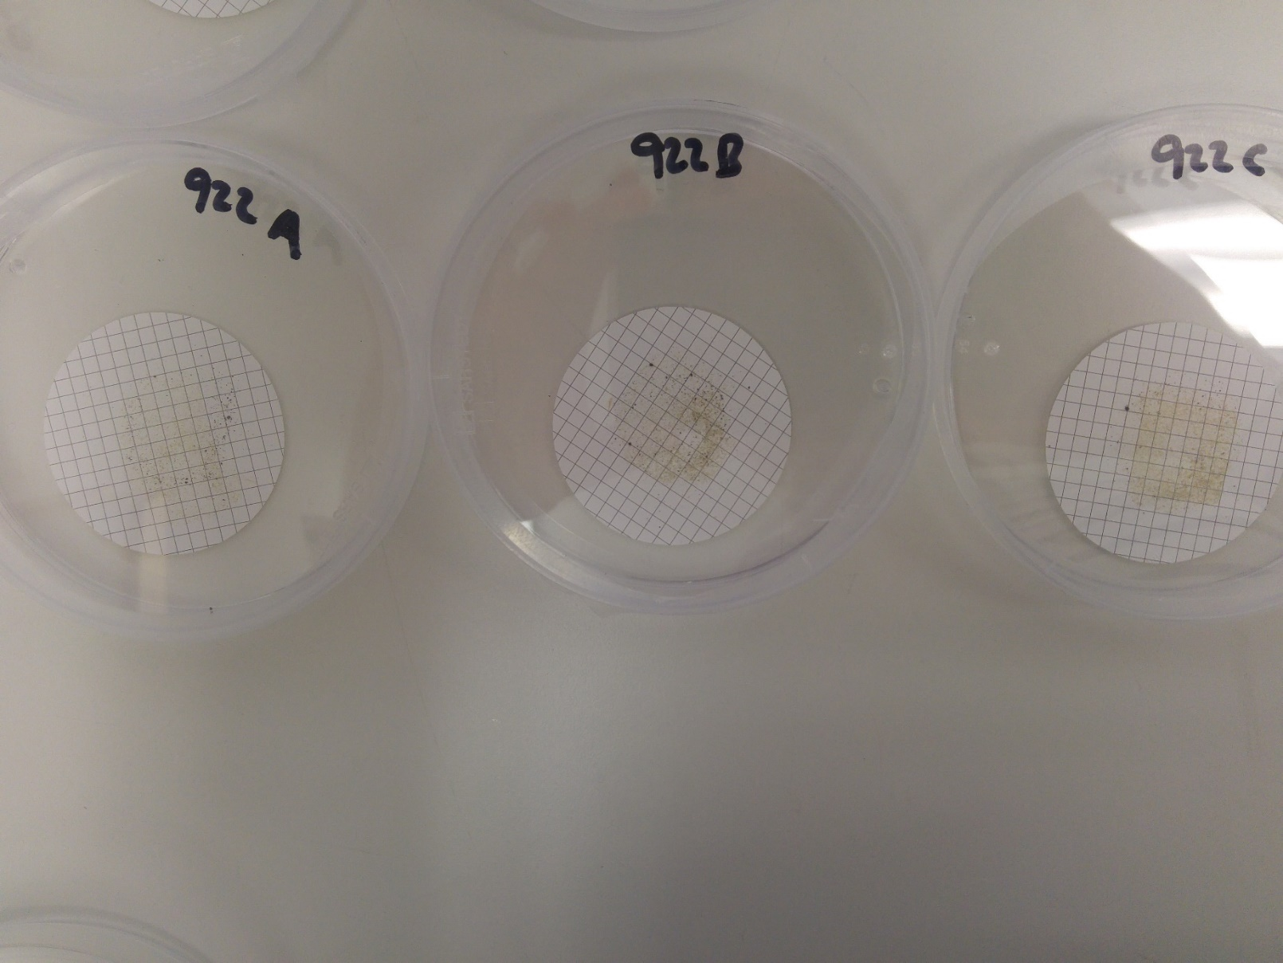

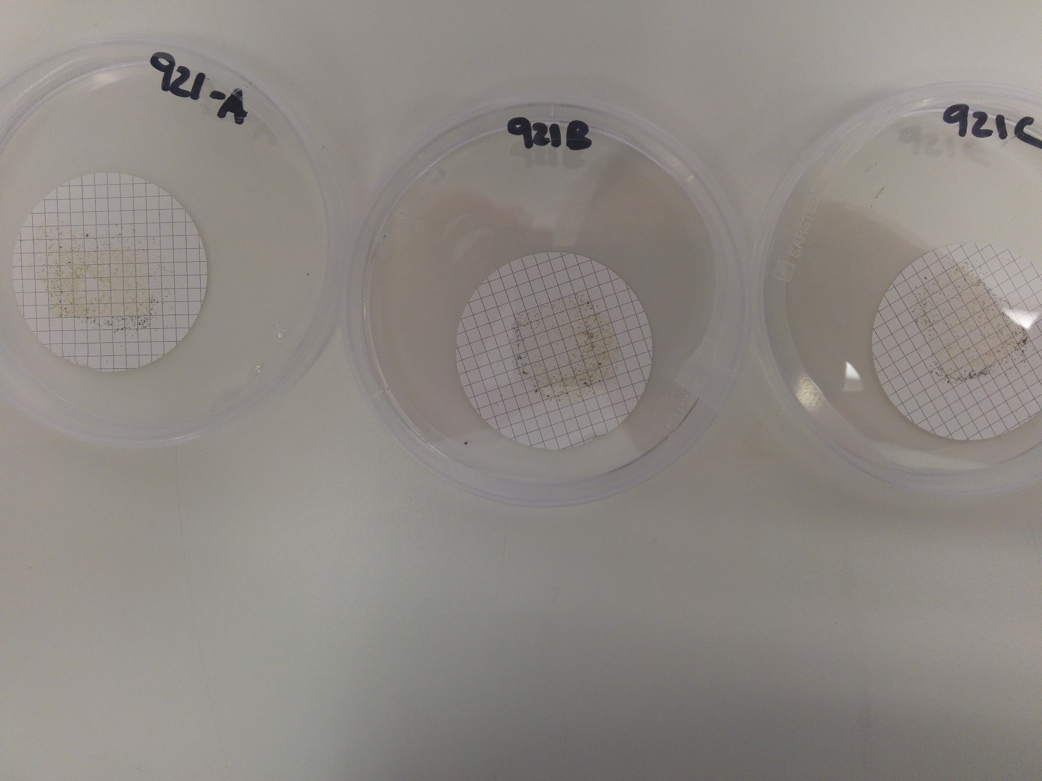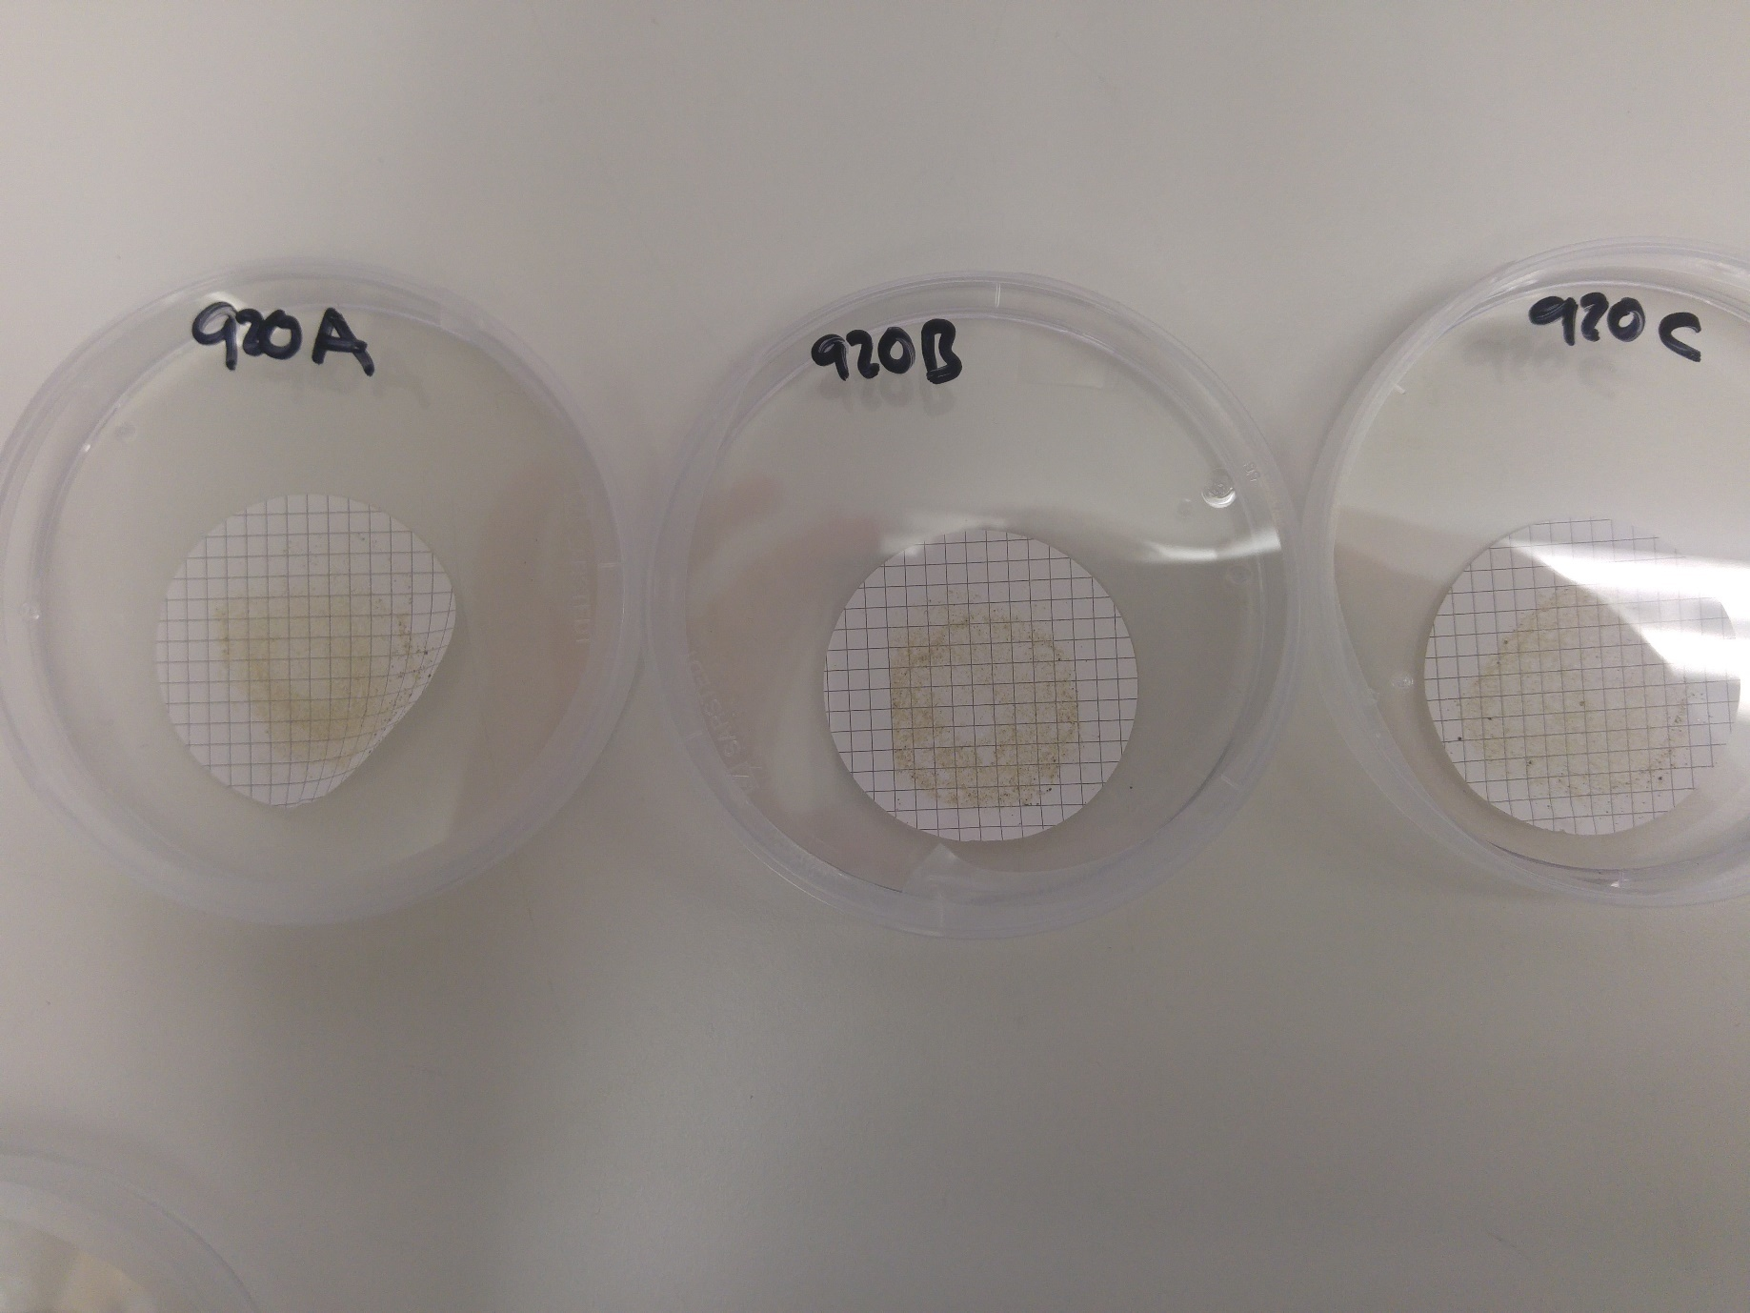

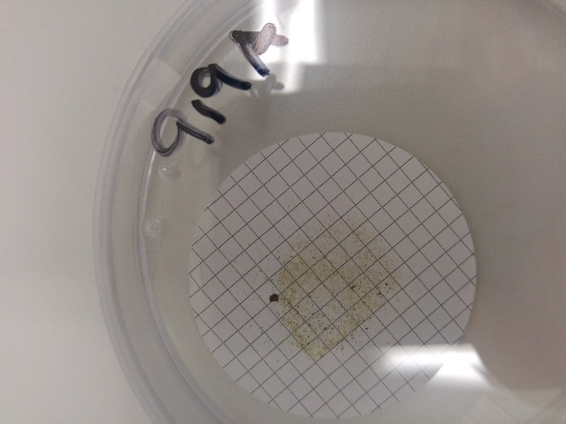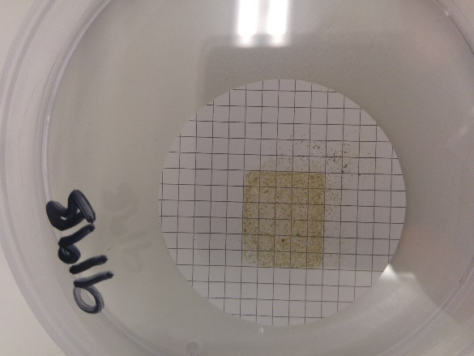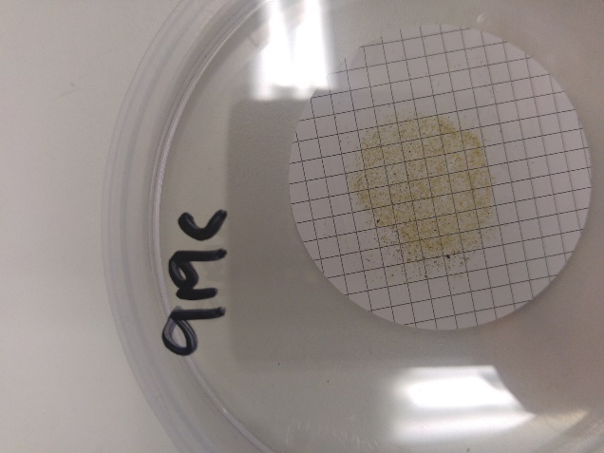

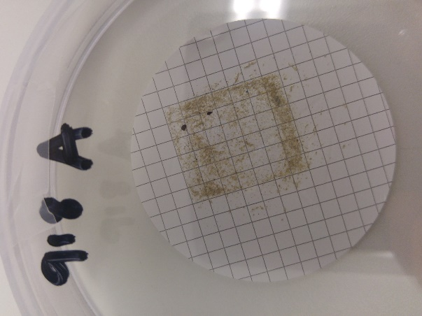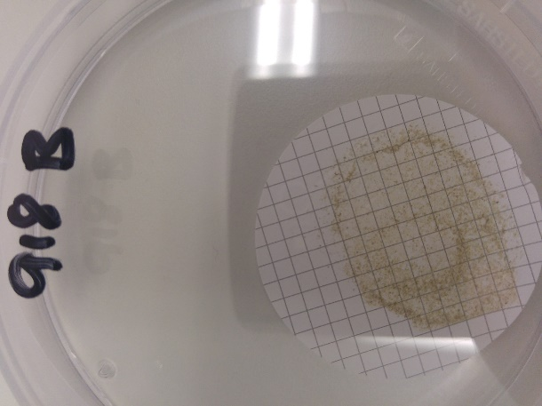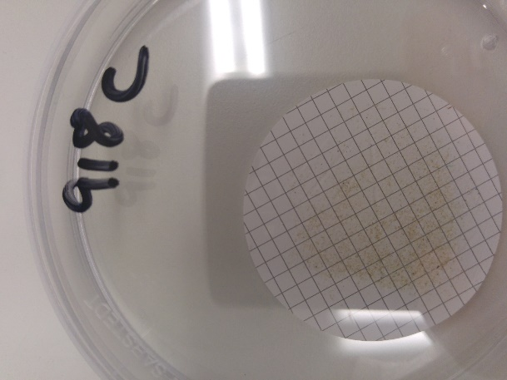

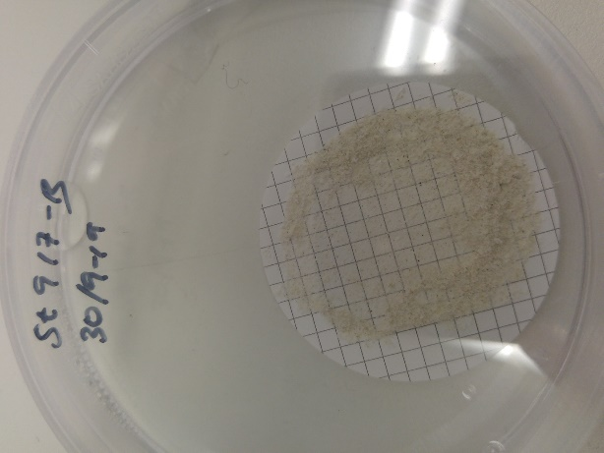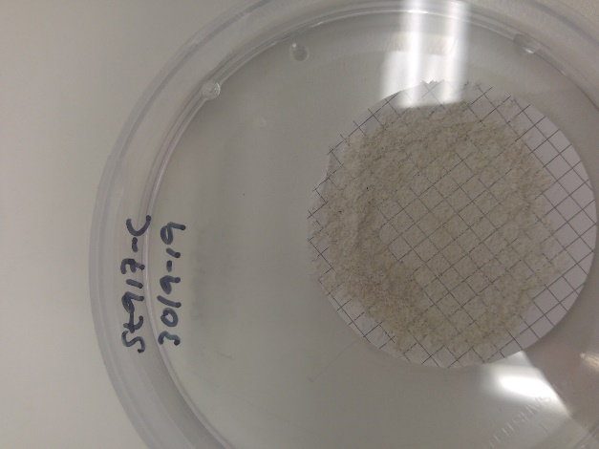

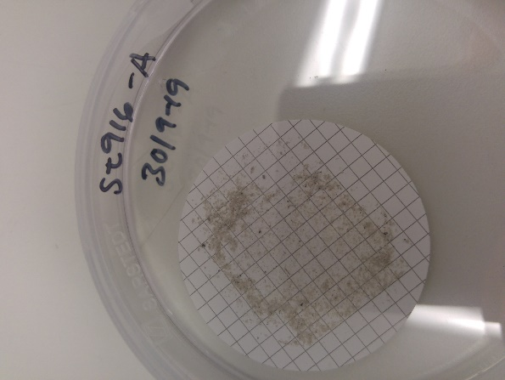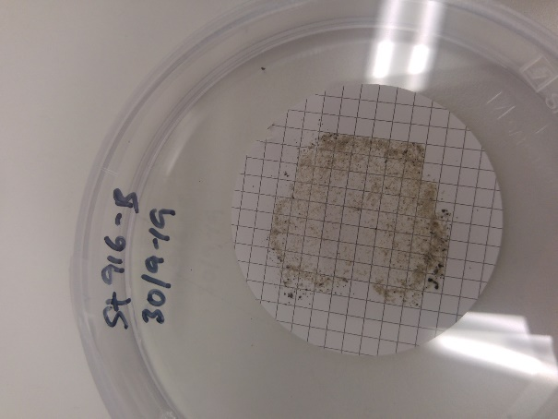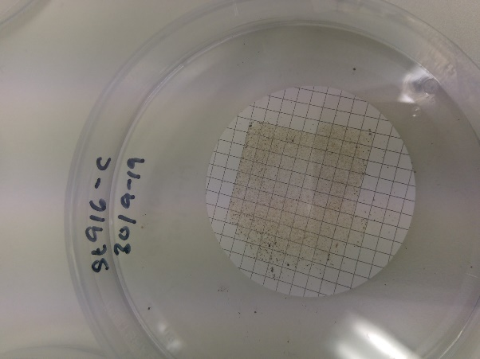

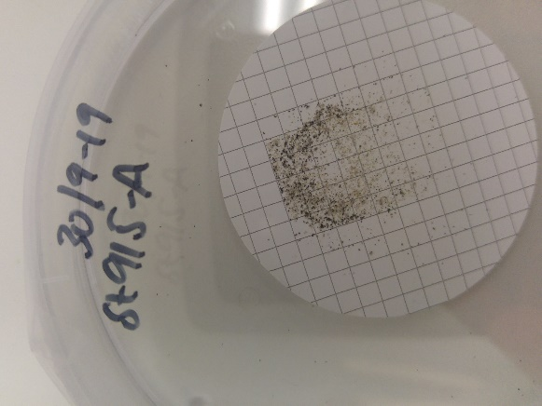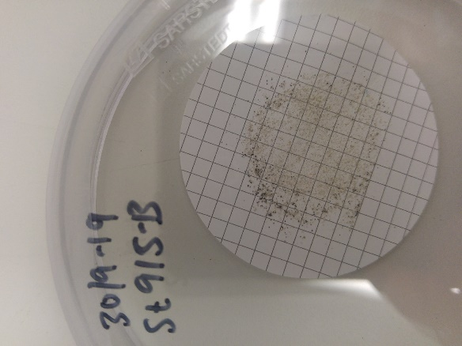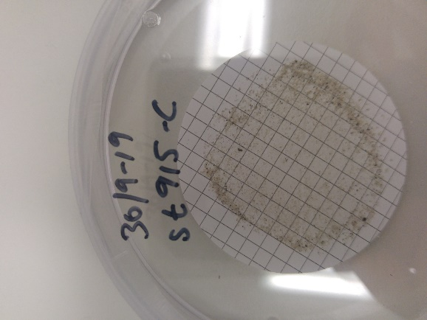

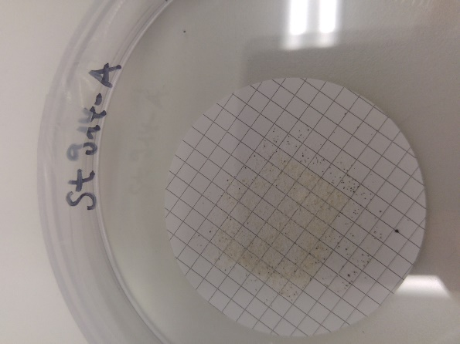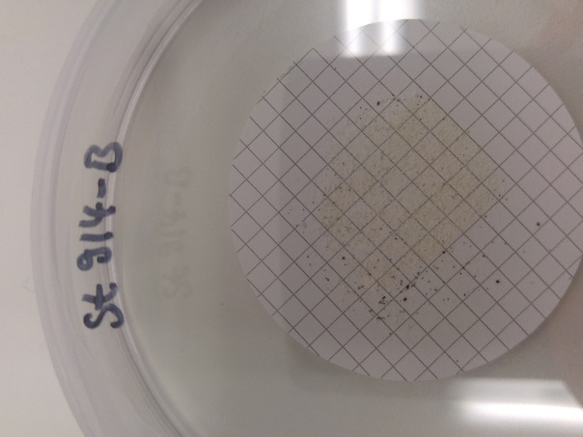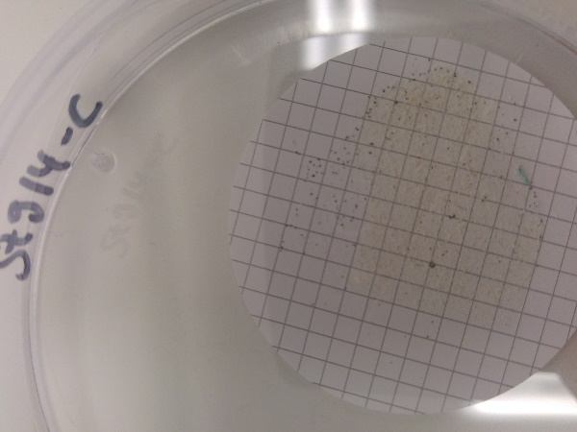

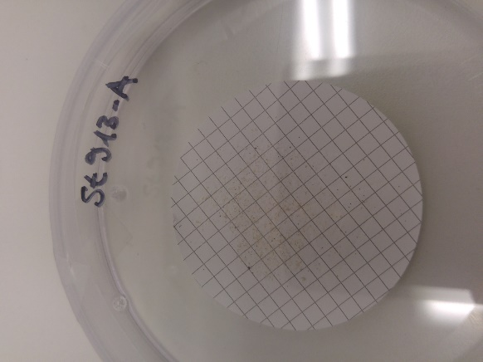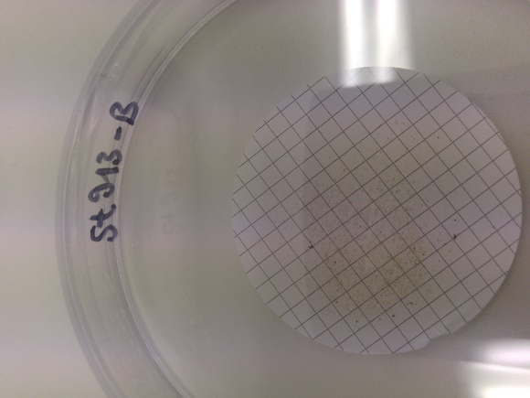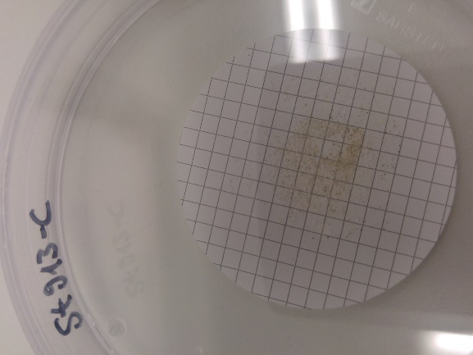

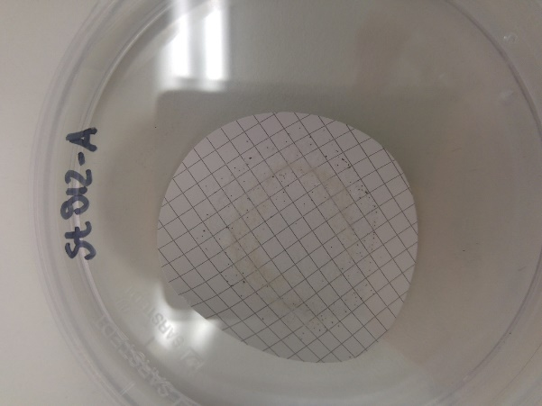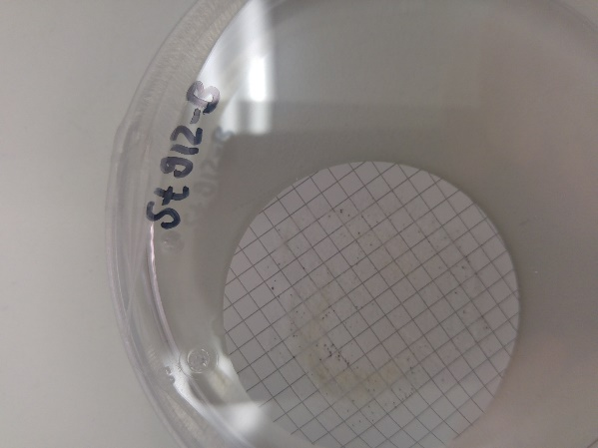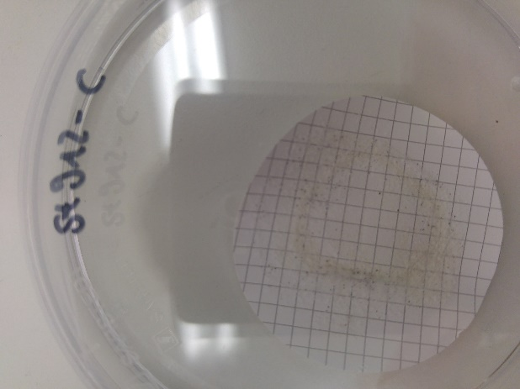

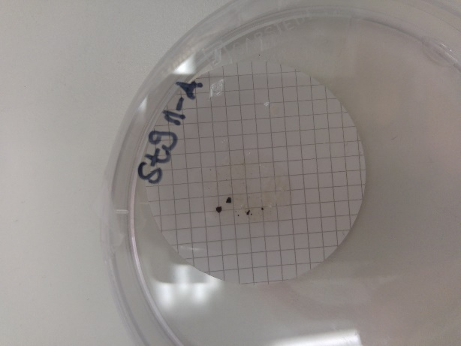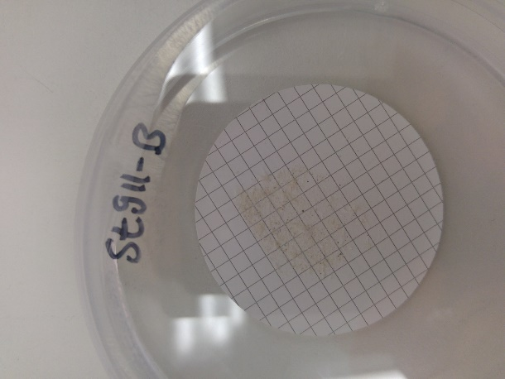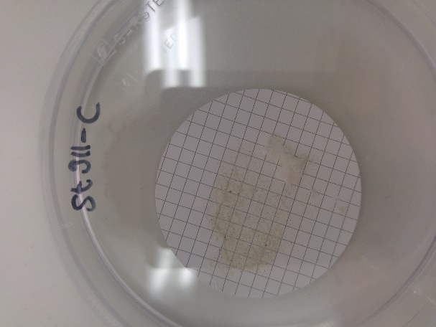

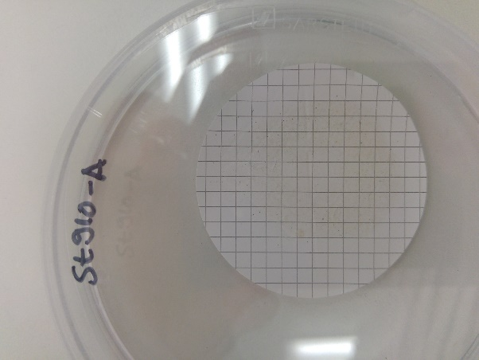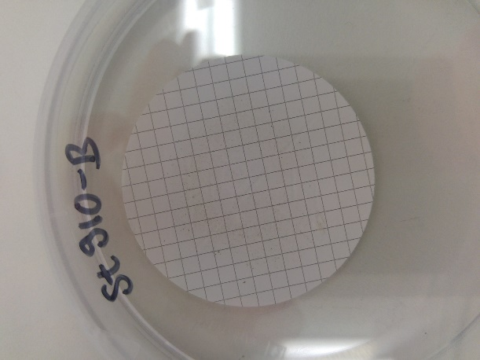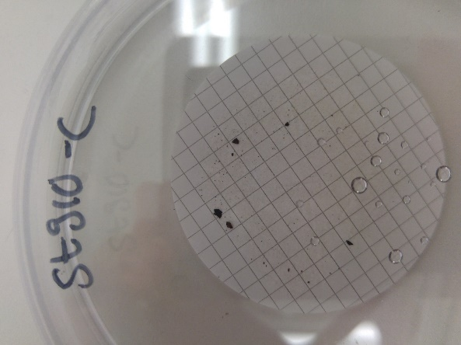

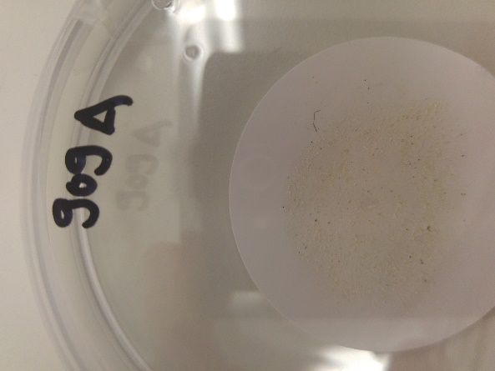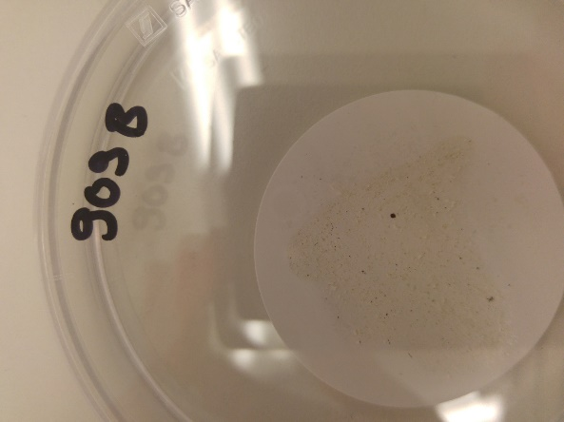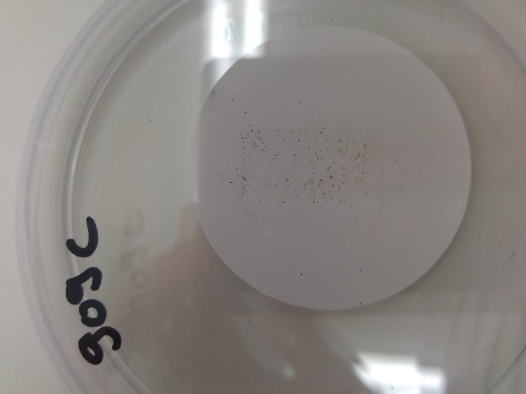

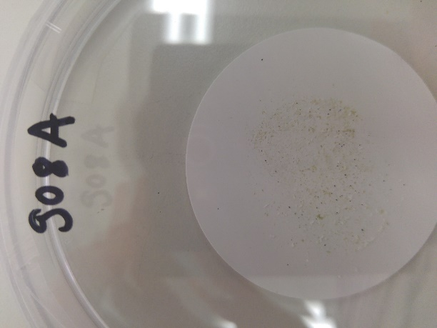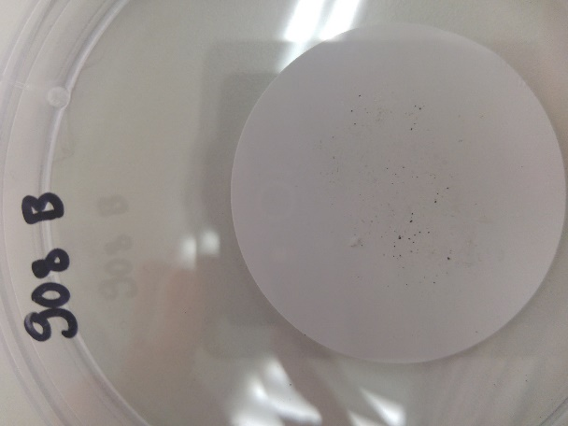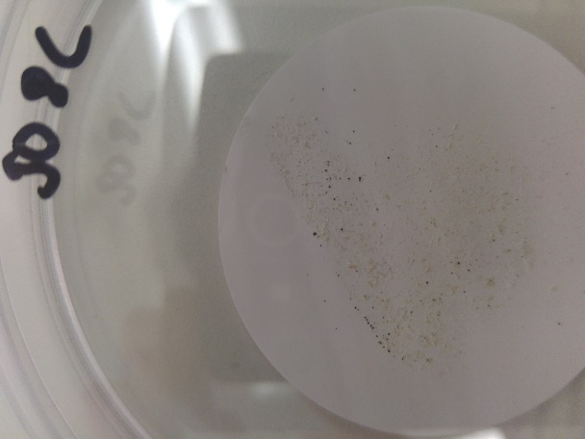

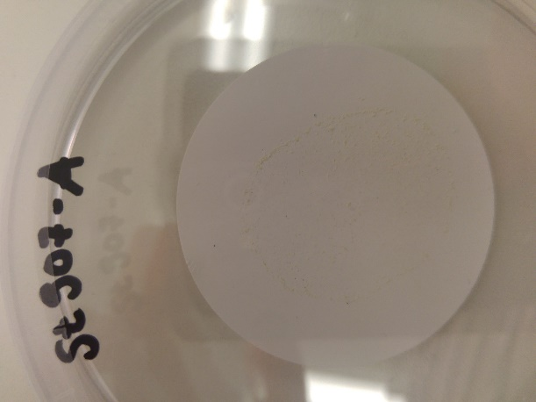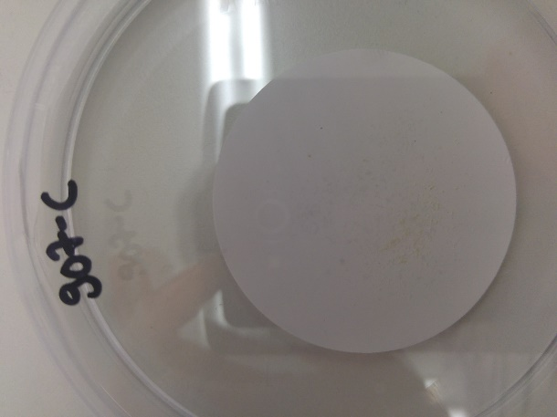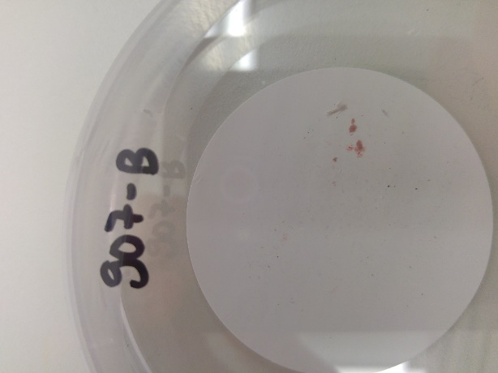

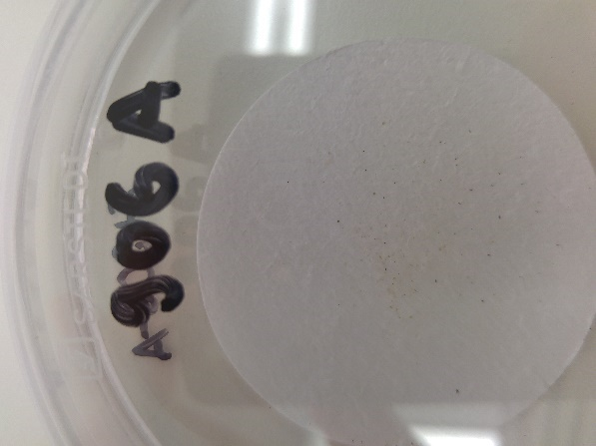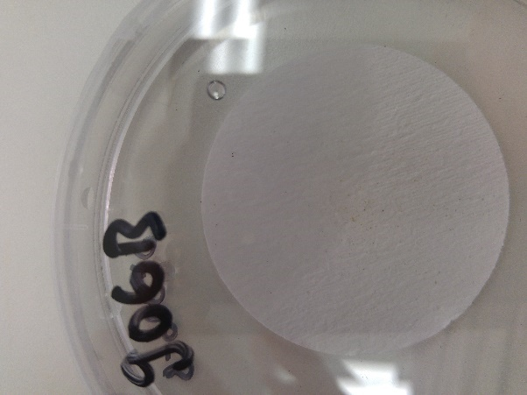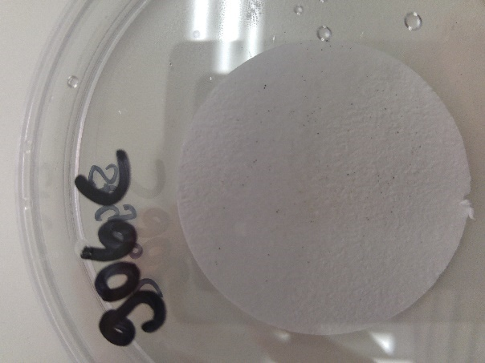

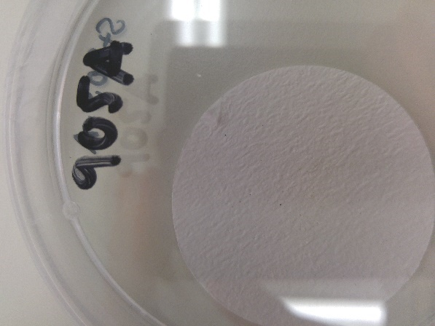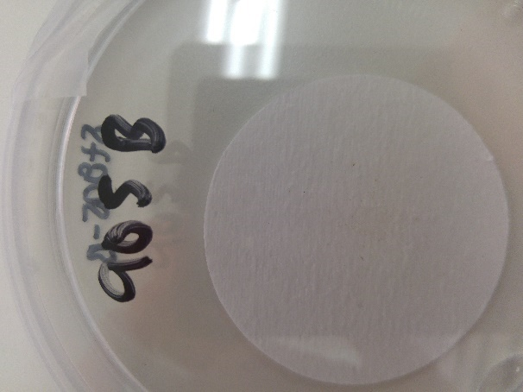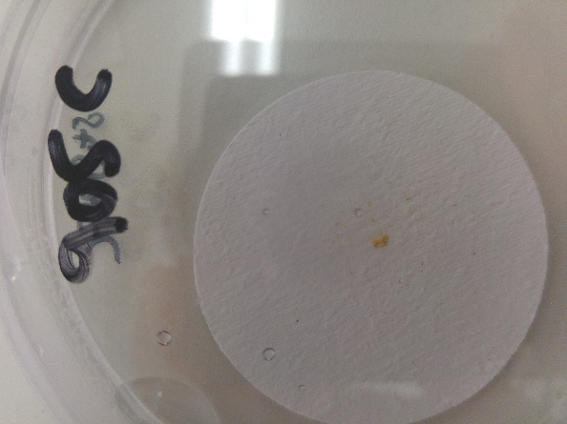

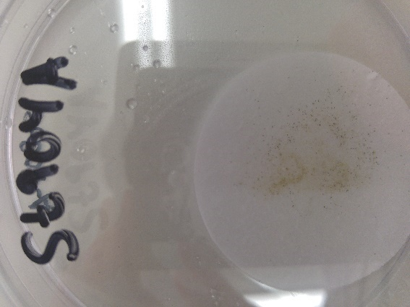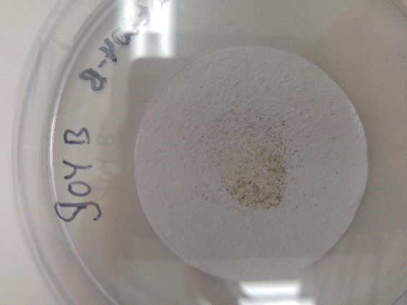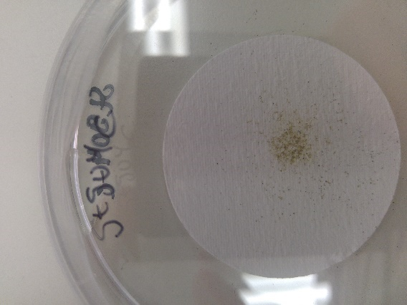

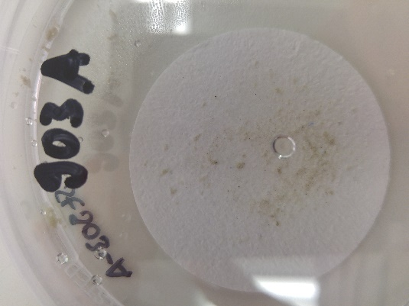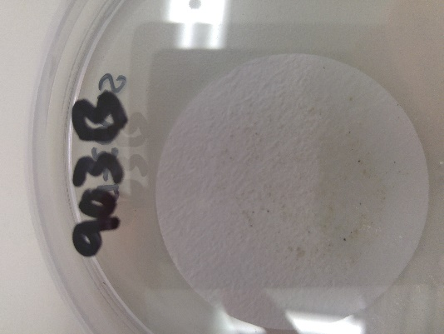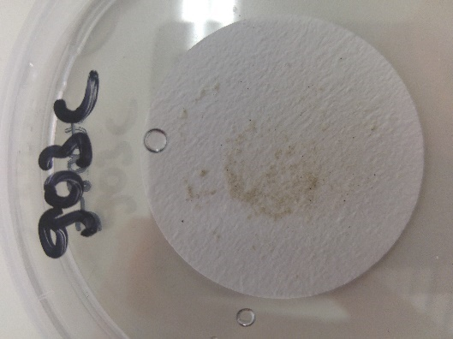

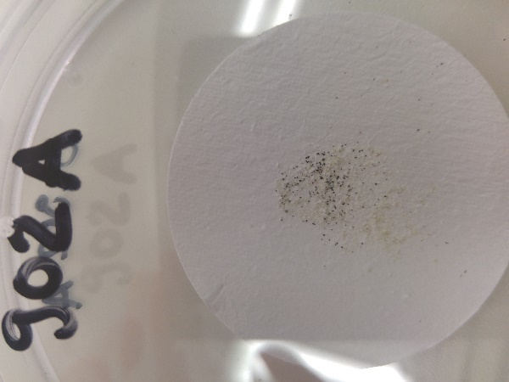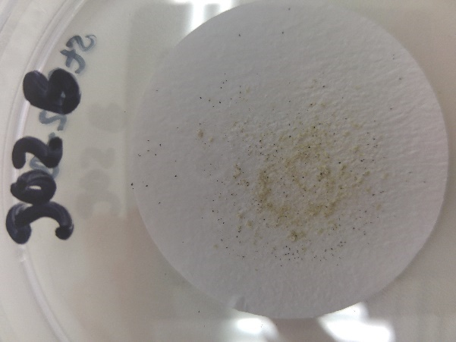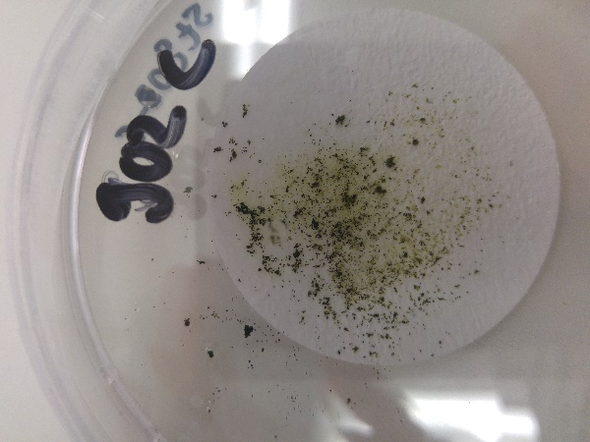

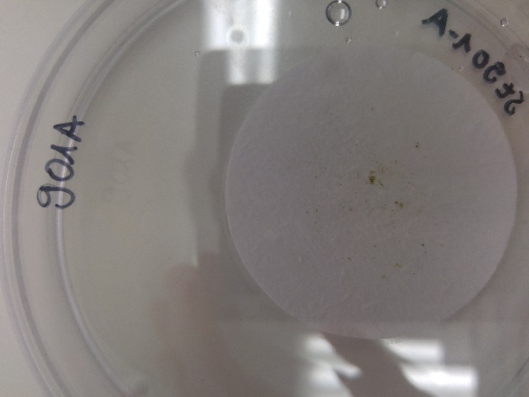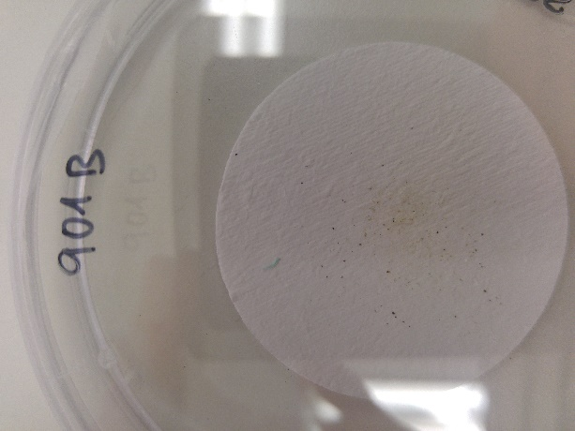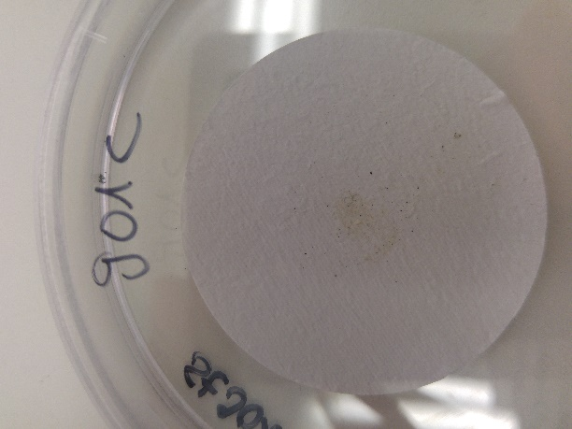

## Data for dry weight before and after digestion

|  |  |  |  |  |
| --- | --- | --- | --- | --- |
| **Sample ID** | **Before digestion (average of 3 samples)**  **[g]** | **Stdev** | **After digestion (average of 3 samples)**  **[g]** | **Stdev** |
| **901** | 0.0565 | 0.0325 | 0.0000 | 0.0000 |
| **902** | 0.2974 | 0.1841 | 0.0000 | 0.0000 |
| **903** | 0.3468 | 0.0557 | 0.0000 | 0.0000 |
| **904** | 0.2270 | 0.0397 | 0.0000 | 0.0000 |
| **905** | 0.0292 | 0.0049 | 0.0000 | 0.0000 |
| **906** | 0.0328 | 0.0066 | 0.0000 | 0.0000 |
| **907** | 0.0420 | 0.0048 | 0.0015 | 0.0012 |
| **908** | 0.0440 | 0.0167 | 0.0016 | 0.0008 |
| **909** | 0.0972 | 0.0286 | 0.0025 | 0.0009 |
| **910** | 0.0227 | 0.0046 | 0.0023 | 0.0007 |
| **911** | 0.0561 | 0.0191 | 0.0037 | 0.0013 |
| **912** | 0.0720 | 0.0197 | 0.0058 | 0.0025 |
| **913** | 0.0315 | 0.0094 | 0.0019 | 0.0002 |
| **914** | 0.0465 | 0.0072 | 0.0047 | 0.0006 |
| **915** | 0.0277 | 0.0147 | 0.0075 | 0.0010 |
| **916** | 0.0435 | 0.0236 | 0.0085 | 0.0021 |
| **917** | 0.3144 | 0.1101 | 0.0394 | 0.0025 |
| **918** | 0.0215 | 0.0071 | 0.0032 | 0.0007 |
| **919** | 0.0706 | 0.0300 | 0.0032 | 0.0003 |
| **920** | 0.0237 | 0.0018 | 0.0064 | 0.0007 |
| **921** | 0.0753 | 0.0131 | 0.0044 | 0.0004 |
| **922** | 0.0383 | 0.0056 | 0.0037 | 0.0004 |

Table : Data for dry weight before and after digestion

## Data for efficiency of digestion

|  |  |  |  |  |  |  |  |  |
| --- | --- | --- | --- | --- | --- | --- | --- | --- |
| Sample ID | Replicate | Filter type | debris after digestion [g] incl. tare | tare of filter (average) | debris after digestion [g] | debris before digestion [g] | % left after digestion | Digestion efficiency [%] |
|
| 901 | A | GF/C | 0.092 | 0.09518 | -0.00318 | 0.026 | 0.0 | 100.0 |
| 901 | B | GF/C | 0.0935 | 0.09518 | -0.00168 | 0.0529 | -3.2 | 103.2 |
| 901 | C | GF/C | 0.0926 | 0.09518 | -0.00258 | 0.0906 | -2.8 | 102.8 |
| 902 | A | GF/C | 0.0936 | 0.09518 | -0.00158 | 0.4761 | -0.3 | 100.3 |
| 902 | B | GF/C | 0.0971 | 0.09518 | 0.00192 | 0.3078 | 0.6 | 99.4 |
| 902 | C | GF/C | 0.0982 | 0.09518 | 0.00302 | 0.1083 | 2.8 | 97.2 |
| 903 | A | GF/C | 0.0994 | 0.09518 | 0.00422 | 0.4068 | 1.0 | 99.0 |
| 903 | B | GF/C | 0.0979 | 0.09518 | 0.00272 | 0.2967 | 0.9 | 99.1 |
| 903 | C | GF/C | 0.098 | 0.09518 | 0.00282 | 0.3368 | 0.8 | 99.2 |
| 904 | A | GF/C | 0.0922 | 0.09518 | -0.00298 | 0.1194 | -2.5 | 102.5 |
| 904 | B | GF/C | 0.0924 | 0.09518 | -0.00278 | 0.0657 | -4.2 | 104.2 |
| 904 | C | GF/C | 0.0931 | 0.09518 | -0.00208 | 0.0419 | -5.0 | 105.0 |
| 905 | A | GF/C | 0.0922 | 0.09518 | -0.00298 | 0.0323 | -9.2 | 109.2 |
| 905 | B | GF/C | 0.0901 | 0.09518 | -0.00508 | 0.0236 | -21.5 | 121.5 |
| 905 | C | GF/C | 0.0922 | 0.09518 | -0.00298 | 0.0317 | -9.4 | 109.4 |
| 906 | A | GF/C | 0.0889 | 0.09518 | -0.00628 | 0.0334 | -18.8 | 118.8 |
| 906 | B | GF/C | 0.0929 | 0.09518 | -0.00228 | 0.026 | -8.8 | 108.8 |
| 906 | C | GF/C | 0.0929 | 0.09518 | -0.00228 |  |  | 100.0 |
| 907 | A | Membrane Filter, 0.22 µm | 0.1408 | 0.14064 | 0.00016 | 0.0474 | 0.3 | 99.7 |
| 907 | B | Membrane Filter, 0.22 µm | 0.1418 | 0.14064 | 0.00116 | 0.0407 | 2.9 | 97.1 |
| 907 | C | Membrane Filter, 0.22 µm | 0.1438 | 0.14064 | 0.00316 | 0.038 | 8.3 | 91.7 |
| 908 | A | Membrane Filter, 0.22 µm | 0.1434 | 0.14064 | 0.00276 | 0.0428 | 6.4 | 93.6 |
| 908 | B | Membrane Filter, 0.22 µm | 0.1415 | 0.14064 | 0.00086 | 0.0279 | 3.1 | 96.9 |
| 908 | C | Membrane Filter, 0.22 µm | 0.1419 | 0.14064 | 0.00126 | 0.0612 | 2.1 | 97.9 |
| 909 | A | Membrane Filter, 0.22 µm | 0.1443 | 0.14064 | 0.00366 | 0.0955 | 3.8 | 96.2 |
| 909 | B | Membrane Filter, 0.22 µm | 0.1429 | 0.14064 | 0.00226 | 0.0623 | 3.6 | 96.4 |
| 909 | C | Membrane Filter, 0.22 µm | 0.1422 | 0.14064 | 0.00156 | 0.0385 | 4.1 | 95.9 |
| 910 | A | Nitrocellulose filter | 0.078 | 0.07605 | 0.00195 | 0.0192 | 10.2 | 89.8 |
| 910 | B | Nitrocellulose filter | 0.0777 | 0.07605 | 0.00165 | 0.021 | 7.9 | 92.1 |
| 910 | C | Nitrocellulose filter | 0.0793 | 0.07605 | 0.00325 | 0.028 | 11.6 | 88.4 |
| 911 | A | Nitrocellulose filter | 0.0782 | 0.07605 | 0.00215 | 0.037 | 5.8 | 94.2 |
| 911 | B | Nitrocellulose filter | 0.0797 | 0.07605 | 0.00365 | 0.0561 | 6.5 | 93.5 |
| 911 | C | Nitrocellulose filter | 0.0815 | 0.07605 | 0.00545 | 0.0751 | 7.3 | 92.7 |
| 912 | A | Nitrocellulose filter | 0.0789 | 0.07605 | 0.00285 | 0.0497 | 5.7 | 94.3 |
| 912 | B | Nitrocellulose filter | 0.0817 | 0.07605 | 0.00565 | 0.0789 | 7.2 | 92.8 |
| 912 | C | Nitrocellulose filter | 0.0851 | 0.07605 | 0.00905 | 0.0873 | 10.4 | 89.6 |
| 913 | A | Nitrocellulose filter | 0.0776 | 0.07605 | 0.00155 | 0.0206 | 7.5 | 92.5 |
| 913 | B | Nitrocellulose filter | 0.0781 | 0.07605 | 0.00205 | 0.0363 | 5.6 | 94.4 |
| 913 | C | Nitrocellulose filter | 0.0781 | 0.07605 | 0.00205 | 0.0375 | 5.5 | 94.5 |
| 914 | A | Nitrocellulose filter | 0.0801 | 0.07605 | 0.00405 | 0.0507 | 8.0 | 92.0 |
| 914 | B | Nitrocellulose filter | 0.0807 | 0.07605 | 0.00465 | 0.0382 | 12.2 | 87.8 |
| 914 | C | Nitrocellulose filter | 0.0816 | 0.07605 | 0.00555 | 0.0507 | 10.9 | 89.1 |
| 915 | A | Nitrocellulose filter | 0.0829 | 0.07605 | 0.00685 | 0.0108 | 63.4 | 36.6 |
| 915 | B | Nitrocellulose filter | 0.0827 | 0.07605 | 0.00665 | 0.0256 | 26.0 | 74.0 |
| 915 | C | Nitrocellulose filter | 0.085 | 0.07605 | 0.00895 | 0.0467 | 19.2 | 80.8 |
| 916 | A | Nitrocellulose filter | 0.0872 | 0.07605 | 0.01115 | 0.0765 | 14.6 | 85.4 |
| 916 | B | Nitrocellulose filter | 0.0844 | 0.07605 | 0.00835 | 0.0314 | 26.6 | 73.4 |
| 916 | C | Nitrocellulose filter | 0.082 | 0.07605 | 0.00595 | 0.0225 | 26.4 | 73.6 |
| 917 | A | Nitrocellulose filter |  |  |  |  |  |  |
| 917 | B | Nitrocellulose filter | 0.1179 | 0.07605 | 0.04185 | 0.2349 | 17.8 | 82.2 |
| 917 | C | Nitrocellulose filter | 0.113 | 0.07605 | 0.03695 | 0.2382 | 15.5 | 84.5 |
| 918 | A | Nitrocellulose filter | 0.0782 | 0.07605 | 0.00215 | 0.0237 | 9.1 | 90.9 |
| 918 | B | Nitrocellulose filter | 0.0799 | 0.07605 | 0.00385 | 0.0272 | 14.2 | 85.8 |
| 918 | C | Nitrocellulose filter | 0.0795 | 0.07605 | 0.00345 | 0.0135 | 25.6 | 74.4 |
| 919 | A | Nitrocellulose filter | 0.0789 | 0.07605 | 0.00285 | 0.1052 | 2.7 | 97.3 |
| 919 | B | Nitrocellulose filter | 0.0793 | 0.07605 | 0.00325 | 0.0522 | 6.2 | 93.8 |
| 919 | C | Nitrocellulose filter | 0.0796 | 0.07605 | 0.00355 | 0.0543 | 6.5 | 93.5 |
| 920 | A | Nitrocellulose filter | 0.0816 | 0.07605 | 0.00555 | 0.0218 | 25.5 | 74.5 |
| 920 | B | Nitrocellulose filter | 0.0832 | 0.07605 | 0.00715 | 0.0253 | 28.3 | 71.7 |
| 920 | C | Nitrocellulose filter | 0.0826 | 0.07605 | 0.00655 | 0.024 | 27.3 | 72.7 |
| 921 | A | Nitrocellulose filter | 0.0806 | 0.07605 | 0.00455 | 0.0654 | 7.0 | 93.0 |
| 921 | B | Nitrocellulose filter | 0.0799 | 0.07605 | 0.00385 | 0.0902 | 4.3 | 95.7 |
| 921 | C | Nitrocellulose filter | 0.0808 | 0.07605 | 0.00475 | 0.0704 | 6.7 | 93.3 |
| 922 | A | Nitrocellulose filter | 0.0792 | 0.07605 | 0.00315 | 0.0321 | 9.8 | 90.2 |
| 922 | B | Nitrocellulose filter | 0.0803 | 0.07605 | 0.00425 | 0.043 | 9.9 | 90.1 |
| 922 | C | Nitrocellulose filter | 0.0797 | 0.07605 | 0.00365 | 0.0397 | 9.2 | 90.8 |

Table : Data for efficiency of digestion

## Email contacts/correspondence

Baseman: Joao Frias [Joao.Frias@gmit.ie](mailto:Joao.Frias@gmit.ie)

Raman: Maria EL RAKWE [Maria.El.Rakwe@ifremer.fr](mailto:Maria.El.Rakwe@ifremer.fr) and [enora.prado@ifremer.fr](mailto:enora.prado@ifremer.fr)

Hafro: Jóhann Garðar Þorbjörnsson [johann.gardar.thorbjornsson@hafogvatn.is](mailto:johann.gardar.thorbjornsson@hafogvatn.is)

Dear Karin,

Thanks for your email and apologies on the delay to reply. I somehow missed your email.

Regarding the questions on your previous email, about implementing a monitoring program on microplastics in your bay in northern Iceland, I will reply to each individual bullet point.

1. Regarding KOH concentration, it is advised to use a 10% KOH solution at a 1:3 sample:solution ratio. This means that the solution should completely cover the sample to be digested. Other research groups around Europe might use different techniques (Fenton reagent, acid solutions such as HNO3, or enzymatic digestion), but this depends on the overall aims and goals of your monitoring programme and on budget and technology available.
2. Regarding the H2O2 concentration, I guess it was mentioned the 30% first, as usually this is the grade you can buy, and then perform dilutions. I would personally recommend not to go above **10% in concentration.** We do a pre-treatment for sediments in our lab and use 3-6%, for seawater, which might include zooplankton I would use 3-6% as well. **I would not go above 10%.** There was some debate while doing the report about this, as there are differences between the research groups, but in light of research conducted in our group and in partners in Denmark and Germany, it is better not to go above 10%.
3. Regarding the volume, I am not entirely sure about that ratio, as that is something that is used in Spain. Nonetheless, I can say that in our group here, for pre-treatment we use approximately 1:2  sample:H2O2.
4. Similarly to the above, it is difficult for me to explain exactly why they do this in Spain. What we do here in the lab is we work with a ratio of 1:3 sample:density separation solution. I believe that the 100 ml is because they used always a very similar volume of sample.
5. I guess that we should have started here with the explanation. So in our laboratory we use glass jars with metal lids, where the whole process is conducted. We use honey and jam jars, which we wash, rinse and clean with mili-Q or ultrapure water, before decontaminating them in an acid bath (0.5-1%). After this process, the jars are washed and rinsed again with ultrapure water. Samples go into these jars, where most of the process happens (pre-treatment, density separation,etc). If you conduct a pre-treatment, with H2O2, please filter this solution as well, as it might contain already microplastics. Mixing is very important here. For biota samples, **using 10% KOH, usually**, contents are digested by 24-72h at room temperature or at a temperature not higher than 40 degrees celsius. The contents of the jars are therefore filtered using a vaccum pump. After inserting the contents in the funnel, you can wash and rinse the sides of the funnel and of the jar using ultrapure water. If you do not mind me asking, what density separation solution are you using? There might be needed more than 1 filter per sample, depending on the amount of organic matter.

Hope that I was of some help, and please do not hesitate to contact us in the future. I apologise again for the late reply, but I was preparing for a course in Denmark, and only arrived to the office this morning.